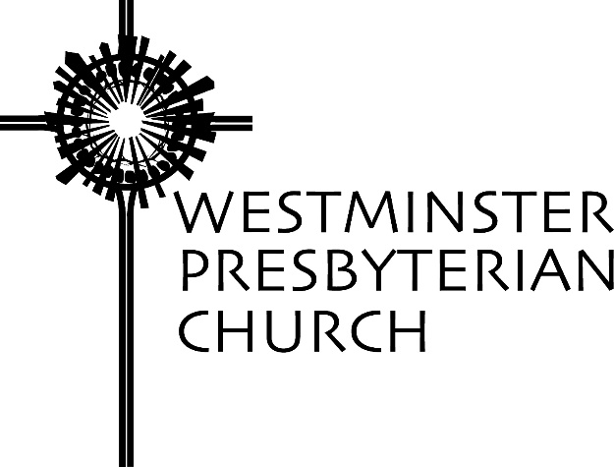

“Choose Life”
Scripture – Deuteronomy 30:11-20
Sermon preached by Gregory Knox Jones
Sunday, February 12, 2017

What if obituaries told the unfettered truth? I’m not saying that most obituaries are padded with malarkey. It is just that most provide a handful of sterile facts, but fail to reveal the person’s core and his/her impact on others.

Here is a typical obituary: “John Smith, Jr. was born in Wilmington, the son of John and Clara Smith. He attended the University of Delaware and worked for Johnson and Johnson for 35 years. He enjoyed reading and vacationing at the beach. Above all, he loved spending time with his family.”

Nothing wrong with it, but all we have is a faint pencil sketch, not a portrait that includes some of the vivid colors of his life. What if obituaries disclosed more of the genuine essence of a person? What if they revealed the uncensored impressions most people had about the deceased?

How about one like this? “Bill Williams always thought of himself as the life of the party. Everyone else thought he had never grown up.”

“Sam’s primary focus in life was making money. And he never tired of reminding people how much he had.”

“When Dorothy was a child, she believed the entire cosmos revolved around her. This continued into her seventies.”

Of course, not everyone’s obituary would be unflattering. Many would be inspiring. “Bob Johnson enjoyed serving food to the homeless and helping to build Habitat Houses. He will be remembered for his generous spirit.”

“Susan Brown did not have an easy life, but she never spoke an unkind word about anyone.”

Today’s passage is part of a long sermon Moses delivers near the end of his life. The time to write his obituary is drawing close. He has led the Hebrew people out of slavery and they have wandered in the wilderness for forty years. He has helped them escape harrowing situations and delivered God’s commandments to them. We find that Moses has brought them to the edge of the place he believed they were destined to reside, and before crossing over the Jordan River, he delivers his parting words.

Whether the Jordan River is to be understood literally or metaphorically, it serves as a threshold. They are about to leave their past and step into their future. They are about to put behind them their wandering, nomadic life and settle in one place. Moses is saying “Your future and your children’s future is before you. What will you make of it? Although you are not pondering this at the moment, in the days ahead, you will be writing your obituary. How will it read?”

In his farewell speech, Moses implores, “Surely, this commandment that I am commanding you today is not too hard for you, nor is it too far away. It is not in heaven, that you should say, ‘Who will go up to heaven and acquire it for us so that we may hear it and observe it?’ Neither is it beyond the sea, that you should say, ‘Who will cross to the other side of the sea for us, and retrieve it so that we may hear it and observe it?’ No, the word is very near to you; it is in your mouth and in your heart.”

Moses has delivered God’s commandments to the people. There is no doubt they are challenging, but Moses declares that the statutes are not so demanding that they are impossible to obey. He encourages them. He is saying, “You have the rules to live by; you can do this.”

Then, it is almost as if someone in the crowd says, “We cannot remember all of the commandments.” Moses had not given them merely ten, but many more.

It is interesting what Moses says. “The commandments are not beyond your reach. You do not have to go to the highest heaven to obtain them. You do not have to sail beyond the sea to discover them. That is because they are written in your soul.”

In other words, “I have given you a long list of God’s commands, those things to do and those things to avoid. But, you do not need to remember every detail because you know in your soul what is merciful and just.”

Then, Moses drives home the gravity of the choice they face. “I have set before you today life and prosperity, death and adversity.” What kind of choice is that? Everyone wants life and prosperity. No one would willingly choose death and adversity. Would they?

What exactly does Moses mean by death? He is not speaking literally – our heart stopping and our brain registering no activity. Death refers to those things that alienate us from God and put us at odds with others. Death is chasing after things that glitter, but turn out to be fool’s gold. Death is a creeping emptiness in your soul. It is the question that keeps nagging your conscience, saying, “What’s the point?” Death is a callous heart where the pain of another does not make a dent on us; where we do not care if people are treated unfairly because of their race or sexual orientation; where we turn a deaf ear to refugees fleeing for their lives.

Ask someone who has admitted he has an addiction and he can tell you about death. Death is living a lie, living in fear, and having no hope. Surely everyone here has had at least one brush with the death of which Moses speaks. And isn’t it maddening when we fail to learn our lesson and choose the same poison we have ingested before?

Moses lays out the stark choice for the people because he will no longer be there for them. He has picked them up when they have fallen. He has shown them the right path when they have strayed, but they will not be able to rely on him in the days ahead. I suspect Moses is worried sick that he had devoted his life to these people, and what if as soon as he is gone they blow it? I can hear Moses pleading with the people in this text. “Please choose life!”

What does Moses mean by life? Earlier in the Book of Deuteronomy, we find that Moses has provided them with commandments that spell out a few of the things that bring life.

I have a prize for anyone, other than a pastor, who can tell me what chapter in Deuteronomy has the Ten Commandments? [Fifth Chapter]

Okay, class, please pull out your hymnal to page 36. We will read the Ten Commandments together.

These are the things that bring life rather than death. Moses adds to the big ten. In the 15th chapter Moses said to cancel the debts of the poor and open your hand to your needy neighbor. In the 24th chapter he said to pay your employees fairly and leave part of your harvest in the field for the alien, the orphan and the widow.

What does Moses mean when he calls on people to choose life instead of death? “The Dean of the Graduate School of Journalism at Columbia compared two autobiographies written by prominent journalists. One was by Al Neuharth, editor, publisher and owner of USA Today. The other was by John Johnson, founder and editor of Ebony magazine. The two had much in common. Both were born into poverty; both lost their fathers at an early age; both were raised by strong, competent mothers; both established media empires; both became extraordinarily wealthy. But that is where the similarities end. Among their differences were their philosophies of life.

Neuharth of USA Today said, ‘Life is a game. To enjoy life to the utmost you must play every game to win. Your won-lost record is the most important thing to measure how you have lived your life.’

Johnson had a different philosophy. He said, ‘We must return to understanding that being an adult requires a total commitment to the community and every child in it.’”¹ Which man chose the path that leads to life?

Returning to our text, Moses knows his days are numbered. He could have made his parting words a recitation of his accomplishments which were momentous. He could have played a part in writing his own obituary, highlighting his leadership that won his people freedom and overcame numerous obstacles. However, he chose instead to provide his people with the wisdom they would need to choose the path that would draw out the best in them.

The German philosopher, Gotthold Lessing, wrote a story called “Nathan the Wise.” A colleague shares a condensed version: “There was once an extraordinarily wise old man named Nathan. Nathan’s long life had brought him prosperity, contentment and the respect of all who knew him. Nathan possessed a ring that had been given to him by his father. And his father had received it from his father, and down through the generations there had come a family story that said this was no ordinary ring. Whoever wore it would possess exceptional wisdom.”

“Nathan had three sons, each of whom he loved dearly and equally. This was both his joy and his dilemma. He could not decide which son should receive the ring when the time came. So when Nathan was on his death bed, he called his jeweler to him and gave the jeweler the ring – the ring that had not left his finger since his father had given it to him. He instructed the jeweler to fabricate two exact duplicates of the ring, even down to the scratches and wear marks. When the jeweler returned, Nathan took the three rings, the original and the two duplicates, and shook them in his cupped hands so that even he did not know which was which.”

“He then called his sons to his bedside one by one, and told each of them the story of the ring and how it had been handed down for generations. Most importantly, the ring brought the wearer great wisdom. He gave a ring to each son and one by one, he charged each of them to tell no one about the ring, especially not to tell his brothers.”

“But brothers being brothers, they soon learned that each of them had been given a ring that was supposed to be unique. The three sons went to their father’s bedside and pleaded with him to tell them which of the three rings was the true ring.”

Their old father looked at them and sighed. He said that he no longer knew which was the true ring, but then he assured them that time would tell.”²

Time will tell which path in life we choose.

In the next 20 seconds of silence, make a vow to yourself and to God – to live a life that leads to a worthy obituary.

NOTES

- Mark Trotter, “An Antidote for Football,” January 28, 1990.
- Michael Lindvall, “The Daughter of Time,” January 12, 2014.

Westminster Presbyterian Church 1502 West 13th Street Wilmington, DE 19806 (302) 654-5214 www.wpc.org

