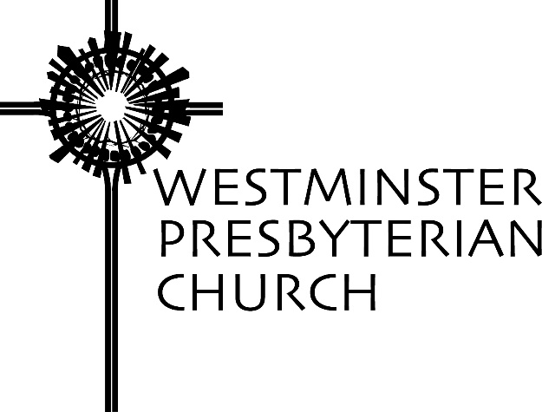

“Nudges”
Scripture – Matthew 2:1-12
Sermon Preached by Gregory Knox Jones
Sunday, January 3, 2016

Would you ever consider adopting a child who is in the foster care system? You know it is a risk and you are bound to wonder if the child’s biological mother took drugs during her pregnancy. You cannot help but wonder what sort of rejection the child has experienced and if permanent damage has been inflicted. Joanna Harader and her husband took the risk.

One day, in a casual conversation with a professor, the subject of children came up. The professor asked what prompted her and her husband to adopt foster care children. The professor was not grilling her, she was merely curious. Joanna answered: “God.”

She knows the professor might have been taken aback by her response, “but it was the only honest one. To say she did not know why they decided to adopt these children would have been a lie. It also would have been less than truthful to lay out all the reasons that she thought might make sense to someone else – social obligation, room in their lives for children…fear of pregnancy. Not that those reasons weren’t mixed in there somewhere, but the only honest answer to (the professor’s) question was: ‘God.’”¹

Joanna made it clear that “God did not lead them to adopt (foster children) in any grand and dramatic way. There was no voice from heaven, no angelic visions, not even a series of inexplicable coincidences. Just a dim gleam on the horizon, a slow but steady wind blowing in a certain direction, an accumulation of prayers and conversations that seemed to nudge them down this one blessed and treacherous path.”²

Our reading from the Gospel of Matthew is the familiar story of the magi following the star to the place where Jesus was born. If we could ask the magi what prompted them to leave the safety and security of their native land to take a journey that was anything but risk-free, what would they have said? From our text, we would assume they would say, “A star.” But is that the complete answer?

I went online to hunt for images of the magi and found what I expected. Nearly every image, whether it was a centuries old painting, a picture from a children’s book or a contemporary sketch, showed three men on camels and in the sky, one prominent star. In most pictures there were several stars, but one stood out among the others.

Let’s think about that. If the star was that conspicuous, why didn’t hundreds of people show up in Bethlehem? If the star was truly outstanding, why did the magi go to Jerusalem instead of Bethlehem? If the star was so eye-catching, why was King Herod shocked to hear about it? Why did he have to ask the magi the exact time the star appeared?

If we pushed the magi to give us a thorough answer to why they made their trip to a foreign land, what would they say? They might say, “Years of study and observation of the night skies allowed us to notice a unique star. Feelings of curiosity about this star welled up inside of us. They might have added: we have enough wealth to make such a trip and to take some pretty impressive gifts along with us. They might have said: We have very understanding wives! We have always had a desire to see this part of the world. Friends encouraged us to make the trip. It sounded exciting.” And perhaps even: “We just felt a nudge that this was what we were supposed to do.”³

What sort of influence does God exert on you? Pastor/professor Ron Byars tells of a Presbyterian minister who, “quite unexpectedly, had a mystical experience in which he sensed that God had spoken to him almost as clearly as one human being speaks to another… His first reaction was to be overwhelmed with awe. His second reaction was to be worried. After thinking it over carefully, he decided he could not simply forget it. It was important enough to take the risk of sharing the experience with the Session of his congregation. The members of the Session loved him and respected him. When he managed to garner the courage to share his story with them, they sat in silence. Then, huddling together, they decided that they would come up with the money to send him to a psychiatrist.”³

If I told the elders on our Session that I had heard God’s voice, I know how they would react. “Uh-oh! Jones is cracking up! Better get him to a doctor quickly! Let’s see if they will do a brain scan.”

I get it. Years ago, when I worked in a hospital for people with mental illness, some experienced hallucinations in which they believed God had spoken to them. When someone says he heard God’s voice, our first thought is to rush them to a mental health professional. But does that fear of being labeled “insane,” or at least “a bit off,” also block us from being genuinely open to God?

New York Times columnist, Nicholas Kristof, wrote about Dr. Tom Catena, from Amsterdam, New York. He is the only doctor permanently based in the Nuba Mountains in Sudan for a population of more than half a million people. Most days, the Sudanese government drops bombs on civilians in these mountains and it is left to Dr. Catena to pry out the shrapnel and surgically remove limbs from women and children. He performs these services without running water, without a telephone, and without an X-ray machine. Eleven bombs have struck his hospital grounds.

He has worked there for eight years. He lives in the hospital and is on call 24/7, except when he is unconscious with malaria which is about once a year. What drives him to do such heroic work? His faith. He says, “I see it as an obligation as a Christian to help.”⁴

I am not suggesting that God is calling each of us to such saintly status. Dr. Catena is exceptional. Most of us know we are not capable of such a sacrifice, and if that is what it means to be a follower of Jesus, then we are pathetic failures. However, God does not call everyone to be a caregiver in the poorest places on the planet. Simply because we are not called to something so noble, so grand, it does not mean that God does not nudge us to live a spiritual life. God urges each of us to live our faith day in and day out – in ways that are both great and small.

Each of us needs to ask ourselves: Are my decisions based primarily on acceptable social norms and cultural values, or am I open to the nudges, the whispers, and the signs that appear to have a divine origin? Am I mainly driven by the opinions of talking heads, political leaders, and armchair philosophers – or the wisdom of God? Am I chiefly influenced by friends, family, co-workers and social status – or am I open to God’s Spirit? Are my prayers essentially a monologue I conduct with God – or do I also attempt to listen?

Many of us live as if God created the world long ago, then retired to a remote corner of the cosmos in some distant galaxy. Yet, the whole point of celebrating the birth of Jesus is to claim that God is not only transcendent – a lofty theological word to mean God is above and beyond our understanding and experience – but God is also immanent – another theological word to mean right here, right now, in the world where we are.

Before we set out in the direction we think God wants us to go, we would like an unambiguous indication that this is truly the right path. We want a divine voice, a bright star, or a clear sign that this is the way to go. But that is not usually how it happens. God is Spirit, and in some ways hidden from us. God nudges, God whispers, God points, God inspires through messengers, stars, Scripture, dilemmas, and moments of crisis.

When someone asks you, “What changed the direction of your life? Why did you take up that particular cause? Why did you head into unfamiliar territory? What prompted such generosity? The sky is full of stars, why did you choose that one?”

You may be able to provide several causes, all of which are true. But underneath it all, I hope the answer is: “God.”

NOTES

- Joanna Harader, “Reflections on the Lectionary,” Christian Century, December 23, 2015, p.21.
- Ibid.
- Ron Byars, “A Meal Under the Oaks,” October 4, 2015.
- Nicholas Kristof, “He is Jesus Christ,” New York Times, June 28, 2015.

Prayers of the People ~ Sudie Niesen Thompson

Eternal God, all glory belongs to you! In the beginning, when darkness covered the face of the deep, you imagined light: radiant sunbeams and shimmering stars, a sun to rule the day and moon to rule the night. You called upon light to pierce the darkness, and creation dawned.

By your Word, all things came into being – trees yielding fruit, birds exploring the skies, creeping things filling the earth, humans bearing your image … You looked upon all you had made – a world waking up to life with you – and declared it ‘good.’

Time and again we failed to reflect your goodness, wandering from your ways of justice and peace. Yet, even when we turned from you, you did not turn from us. Ever faithful, you spoke through the voices of prophets, calling us out of the shadows into your marvelous light.

In the fullness of time, you sent your son – the Word made flesh – to live among us. He is the one who dispels the darkness of chaos, fear and despair. So we rejoice, O God, as we kneel like the magi before the manger and welcome the Christ child into our hearts. May his light fill us with hope for this world shrouded in darkness, and illumine our path as we seek to follow the one who embodied your goodness.

As we gather at this table, we remember the child born to be the light of the world. We give thanks that Jesus grew in wisdom and years, bringing good news to the poor and proclaiming release to the captives. We give thanks that he broke bread with sinners and outcasts, and with friends who would betray and deny him. We give thanks that Jesus loved us enough to suffer the cross and to shatter its power. We give thanks that he burst from the tomb, showing once and for all that the light shines in the darkness – a light no darkness can overcome.

Eternal God, pour out your Spirit upon us that we might experience the presence of the Word made flesh. Unite us with Christ, and sustain us to continue his work in this broken and hurting world. Fill us, we pray, with the bread of heaven and the cup of new life, that we might find strength to proclaim your peace, hope, joy and love to all who crave good news. And send us out into the world as witnesses to your glorious light.

We pray in the name of Jesus Christ, the Word made flesh, who gave us words to pray: Our Father …
Westminster Presbyterian Church 1502 West 13th Street Wilmington, DE 19806 302-654-5214 www.wpc.org

