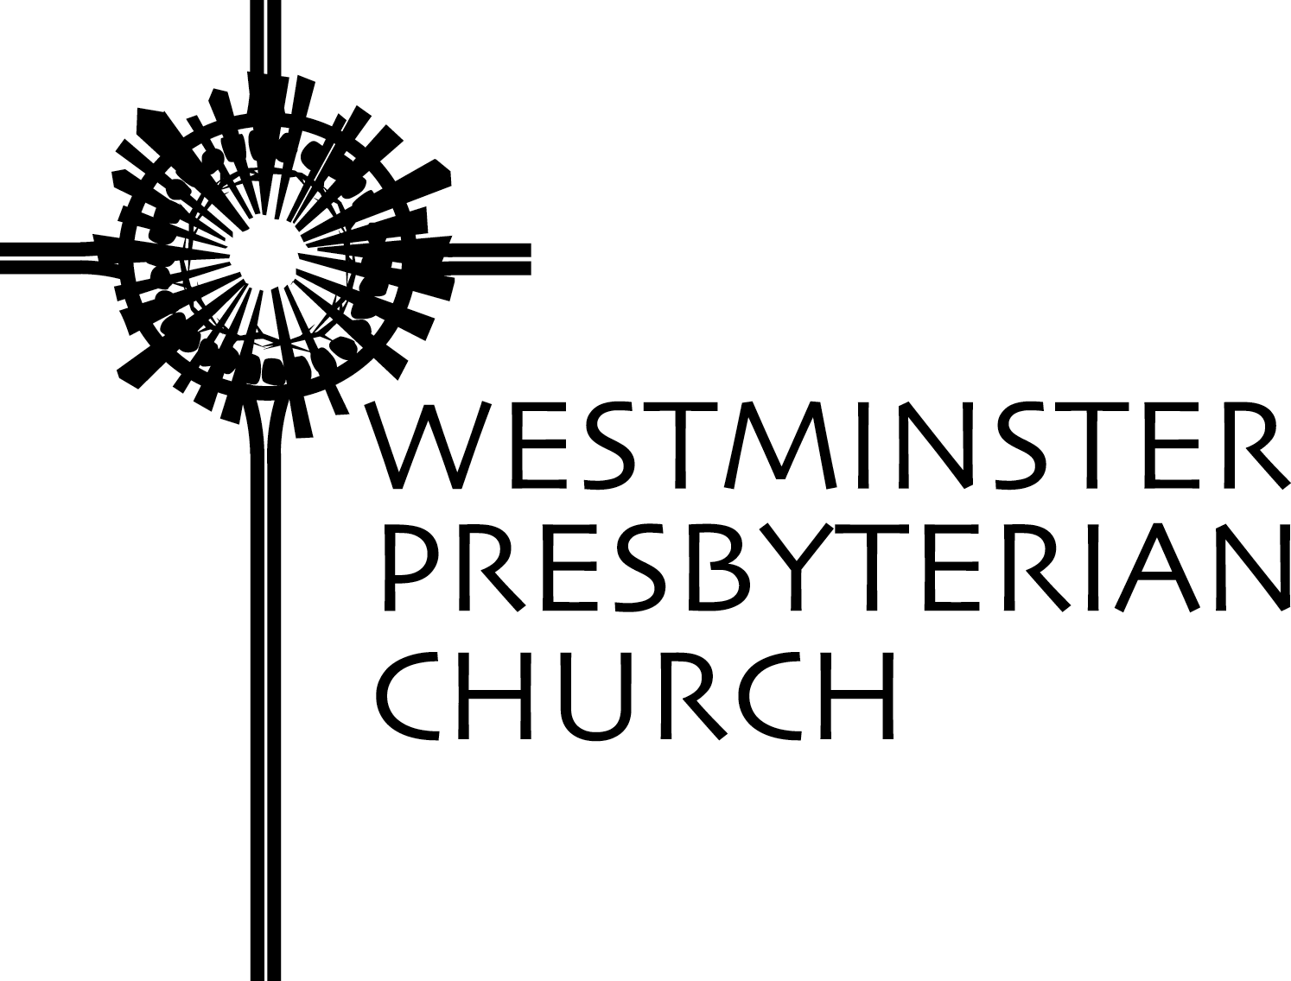

Sunday Bulletin

May 11, 2008
Pentecost Sunday

Sunday Worship Bulletin

October 4, 2009
World Communion Sunday

Westminster Presbyterian Church extends an enthusiastic welcome, in Christ’s name,
to all who would worship here or join us in fellowship.
We affirm that there can be no exclusion within the body of Christ.

We invite all children of God to join us as disciples of Christ
and participate fully in the life of our congregation.

1502 West 13th Street · Wilmington, DE 19806
302-654-5214 · Fax: 302-654-5706 · www.wpc.org

Welcome to Westminster

Whether you are worshiping at Westminster for the first time or returning for a visit,
we sincerely welcome you in the name of Christ!

- Following our 9:00 a.m. worship service, we invite you to meet today’s “ambassador,” Julia Stone, at the back of the sanctuary. She will have a gift for you, and can share information regarding our many ministries for children, youth and adults. She can also guide you to the hospitality area to enjoy fellowship or lead you on a tour of the church.
- Children are welcome in worship! Westminster’s Kids’ Notes and worship bags are available each Sunday from the ushers. Kids’ Notes, a weekly companion to Westminster’s morning worship, emphasizes listening and seeing during worship. The bags include storybooks for children of all ages, coloring paper and crayons, a children’s bulletin for those age three to six, and bookmarks for hymns and Scripture.
- The Lord’s Supper is celebrated today at both services.
- Worship Aids - Large print Presbyterian Hymnals and hearing devices may be obtained from any usher.
- Would you like to know more? Check out our website at www.wpc.org.

This Morning at Westminster

8:45 – Noon Child Care for Cribbery (birth – toddler)

9:00 a.m. Traditional Worship Service with Westminster Choir and organ

- After Time With Our Children, if you wish, your children may
leave the Sanctuary and go to:

- Godly Care-A unique opportunity for children ages 2 – 4 to get to know God through music, crafts, prayers and stories. Classes are in the Under Six Classrooms A & B.

- Godly Play-Children in kindergarten through second grade gather in
the Ruth Christie Room to learn the language of God’s people through
sacred space, stories, parables and liturgical actions.

- Godly Kids – Worship education for children in grades 3 and 4 in the Meeting Room. Godly Kids return to the sanctuary during the final hymn and sit together until their parents meet them following the postlude.

10:10 a.m. Prime Time Sunday School Classes for all ages. For a listing of Adult Education classes, see page 6.

11:15 a.m. Worship with old hymns, new songs, and creative liturgy. Children are always welcome in worship, however, childcare is available in Under Six for ages 2 – Grade 2.

Hospitality and Fellowship
The Holy Toast Café, located in Community Hall, is open from 8:30 a.m. to 11:15 a.m.
Coffee, tea and fellowship are free. Breakfast foods are available for one dollar per item.
ORDER OF WORSHIP AT 9:00 A.M.

Preparation for Worship
We all drink from one water, we all breathe from one air, we rise from one ocean, and we live under one sky. Remember we are one. The newborn baby cries the same, the laughter of children is universal, everyone’s blood is red, and our hearts beat the same song. Remember we are one. We are all brothers and sisters, only one family, only one earth, together we live and together we die. Remember we are one. Peace be on you, brothers and sisters, peace be on you.
Anwar Fazal, Recipient, Right Livelihood Award, Malaysia

Organ Prelude Trio Sonata no. 1 in E-flat major J. S. Bach
I. Allegro

Welcome and Announcements

*Passing of the Peace

Call to Worship

In the beginning, God created life.
We gather to celebrate life!
In the beginning, life was given in love.
We gather to give our lives in love!
In Christ’s Spirit of love, let us worship God.

*Hymn No. 460 “Holy God, We Praise Your Name” Grosser Gott

Call to Confession
Our loving Creator invites us to confession.
Let us make an honest assessment of our lives so that healing may begin.

Prayer of Confession
Great God: your Son called disciples, and prayed for their unity.
Forgive our divisions and our lack of charity
toward people whose customs are different,
or whose creeds conflict with what we believe.
Forgive our arrogance that insists our way is the only way,
and refuses to consider new possibilities.
Draw the church together in loyalty to our Lord and Savior, Jesus Christ. Amen.

Assurance of God’s Forgiveness
God liberates those who seek forgiveness.
We are free to live as Christ lived.

Time With Our Children Greg Jones

Prayer for Illumination Jen Barrington, Lay Liturgist

Scripture Lesson Mark 9:38-50 New Testament, page 39

At the asterisk (*), please stand as you are able.

Sermon “Casting Out Demons” Greg Jones

Offering
During the offering, please sign your name and pass the red folders down each row.
As folders are returned to the center aisle, note the names of fellow worshippers on your pew.

Offertory Anthem “Ave Verum Corpus” Nicholas White
Westminster Choir
Diana Milburn, soprano

Ave verum corpus, Hail, true Body,
natum de Maria Virgine: born of the Virgin Mary,
Vere passum, Who has truly suffered,
immolatum in cruce pro homine; was sacrificed on the cross for mortals,
Cujus latus perforatum, Whose side was pierced,
unda fluxit sanguine; whence flowed water and blood;
Esto nobis praegustatum Be for us a foretaste (of heaven)
in mortis examine. during our final examining.
O Jesu dulcis, O Jesu pie, O Jesu sweet, O Jesu pure,
O Jesu Fili Mariae, O Jesu, Son of Mary,
miserere mei. Amen. have mercy upon me. Amen.

Celebration Of The Lord’s Supper

Invitation to the Lord’s Table

Throughout God’s world this day Christian churches are celebrating the Lord’s Supper
as one family sharing a meal together.
Our sisters and brothers in Europe, Africa, Asia and in all lands,
join us in lifting the bread of life and the cup of salvation.
Nothing shall deter our mission to go forth as disciples
into every city, town and village sharing God’s love.
In Christ our differences are overcome
by a fervent hope for peace throughout our troubled world.

*Hymn “As a Fire Is Meant for Burning” Holy Manna

As a fire is meant for burning with a bright and warming flame,
so the church is meant for mission, giving glory to God's name.
Not to preach our creeds or customs, but to build a bridge of care,
we join hands across the nations, finding neighbors everywhere.

We are learners; we are teachers; we are pilgrims on the way.
We are seekers; we are givers; we are vessels made of clay.
By our gentle, loving actions, we would show that Christ is light.
In a humble, listening spirit we would live to God's delight.

As a green bud in the springtime is a sign of life renewed,
so may we be signs of oneness 'mid earth's peoples, many hued.
As a rainbow lights the heavens when a storm is past and gone,
may our lives reflect the radiance of God's new and glorious dawn.

Words: Ruth Duck © 1992 GIA Publications, Inc.
Used with permission: Onelicense.net #A-715702

The Great Prayer of Thanksgiving
The Lord be with you.
And also with you.
Lift up your hearts.
We lift them to the Lord.
Eternal God, you create a dynamic universe...

…who forever sing to the glory of your name:

Sanctus
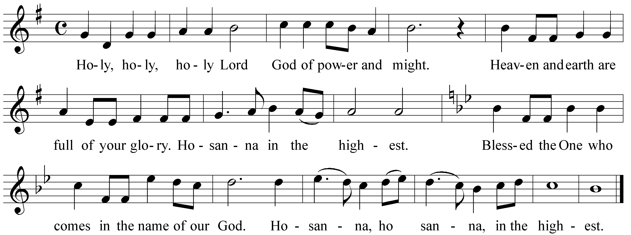

Music © Grant Lynn Ford; used with permission.

We praise you, most Holy God…

Lord’s Prayer (page 16 in The Presbyterian Hymnal, using “debts” and “debtors”)

Words of Institution

Communion of the People

Music During Communion Trio Sonata no. 1 Bach
II. Adagio

Prayer following Communion

*Hymn No. 508 “For the Bread Which You Have Broken” kingdom “ ”

Benediction

Organ Postlude Trio Sonata no. 1 Bach
III. Allegro
*Going Forth

If you are visiting with us for the first time, we invite you to meet today’s ambassador, Julia Stone,
following the service at the rear of the sanctuary to receive a gift and information.

ADULT EDUCATION CLASSES

ADULT EDUCATION CLASSES
Today, 10:10 a.m. – 11:00 a.m.

Living Fully Dying Well – Classroom 5 Led by Dr. Anne Ledbetter, today through November 8. Our best decisions about life’s most important events are seldom made in a time of crisis. This study for all ages inspires us to talk openly about faith and mortality. What does our faith say about death? What are the opportunities and challenges of aging? How may we recreate our lives to live fully, joyfully, productively, as long as this life lasts?
Cost of course book is $10.

Westminster By Heart – Rodney Chapel Meeting Room Led by Biblical Storytellers Shelley Gnade and Mary-beth Howard. This offers a unique opportunity to study scripture, foster a personal connection to stories of the Bible, and develop skills for telling Scripture in worship. Be a part of expanding the art of biblical storytelling, connecting to the stories of our faith, and sharing the story with the congregation. Join us whether you are simply interested in Bible study, or know that you want to develop skills in Biblical storytelling.

Parenting – Ruth Christie Room Group led, with regular guest Yvonne Nass, Parenting Consultant on the first Sunday of the month. Class discussion built around a powerful DVD series called Nooma. Each viewing session deals with a particular “real life” topic as seen through Jesus’ perspective, and serves as a means to generate discussion and sharing. Nooma encourages group members to search, question, and join the conversation.

Enough – Discovering Joy Through Simplicity & Generosity – Daughtry House Classroom Led by class participants through October 18. Enough is DVD-series with presenter Rev. Adam Hamilton, Pastor of Church of the Resurrection (UMC) in Leawood, Kansas. Enough is an invitation to rediscover the Bible’s wisdom on prudent financial practices. Find the keys to experiencing contentment, overcoming fear, and discovering joy through simplicity and generosity. This program could change your life by changing your relationship with money.

Paul’s Letter to the Church in Rome – Classroom 6 - Leader, Dr. Greg Jones, today through October 25. Paul’s Letter to the Romans is the longest of Paul’s letters and is widely acclaimed to be his masterpiece. This letter, more than any other, spells out Paul’s understanding of the life, death and resurrection of Jesus. It has had a major impact on the doctrines of the church since early times. However, there is by no means a consensus on the interpretation of Paul’s thinking. This class is a combination of lecture and discussion as we wrestle with Paul’s message and what it means for our lives today.

Beginning Today, 10:10 a.m. – 11:00 a.m.

Paul’s Letter to the Church in Rome - Classroom 6 - Leader, Dr. Greg Jones, today through October 25. Paul’s Letter to the Romans is the longest of Paul’s letters and is widely acclaimed to be his masterpiece. This letter, more than any other, spells out Paul’s understanding of the life, death and resurrection of Jesus. Further, it has had a major impact on the doctrines of the church since early times. However, there is by no means a consensus on the interpretation of Paul’s thinking. This class is a combination of lecture and discussion as we wrestle with Paul’s message and what it means for our lives today.

Enough – Discovering Joy Through Simplicity & Generosity – Daughtry House Classroom A DVD-series with presenter Rev. Adam Hamilton, Pastor of Church of the Resurrection (UMC) in Leawood, Kansas. Led by class participants through October 18. Enough is an invitation to rediscover the bible’s wisdom on prudent financial practices. Find the keys to experiencing contentment, overcoming fear, and discovering joy through simplicity and generosity. This program could change your life by changing your relationship with money.

Parenting – Ruth Christie Room Group led, with regular guess Yvonne Nass, Parenting Consultant on the first Sunday of the month. Class discussion built around a powerful DVD series called Nooma. Each viewing session deals with a particular “real life” topic as seen through Jesus’ perspective, and serves as a means to generate discussion and sharing. Nooma encourages group members to search, question, and join the conversation.

Westminster By Heart – Rodney Chapel Meeting Room Led by Biblical Storytellers Shelley Gnade and Mary-beth Howard. This new class offers a unique opportunity to study scripture, foster a deeper personal connection to stories of the Bible, and develop skills for telling Scripture on a regular basis in worship. Be a part of expanding the art of biblical storytelling, connecting to the stories of our faith, and sharing the story with the congregation. Join us whether you are simply interested in Bible study, or know that you want to develop skills in Biblical storytelling.

Living Fully Dying Well – Classroom 5 Led by Dr. Anne Ledbetter today through November 15. Our best decisions about life’s most important events are seldom made in a time of crisis. This study for all ages inspires us to talk openly about faith and mortality. What does our faith say about death? What are the opportunities and challenges of aging? How may we recreate our lives to live fully, joyfully, productively, as long as this life lasts?
Cost of course book is $10.

ORDER OF WORSHIP AT 11:15 A.M.

Preparation for Worship
We all drink from one water, we all breathe from one air, we rise from one ocean, and we live under one sky. Remember we are one. The newborn baby cries the same, the laughter of children is universal, everyone’s blood is red, and our hearts beat the same song. Remember we are one. We are all brothers and sisters, only one family, only one earth, together we live and together we die. Remember we are one. Peace be on you, brothers and sisters, peace be on you.
Anwar Fazal, Recipient, Right Livelihood Award, Malaysia

Welcome and Announcements

Call to Worship

In the beginning, God created life.
We gather to celebrate life!
In the beginning, life was given in love.
We gather to give our lives in love!
In Christ’s Spirit of love, let us worship God.

*Song “Gather Us In”
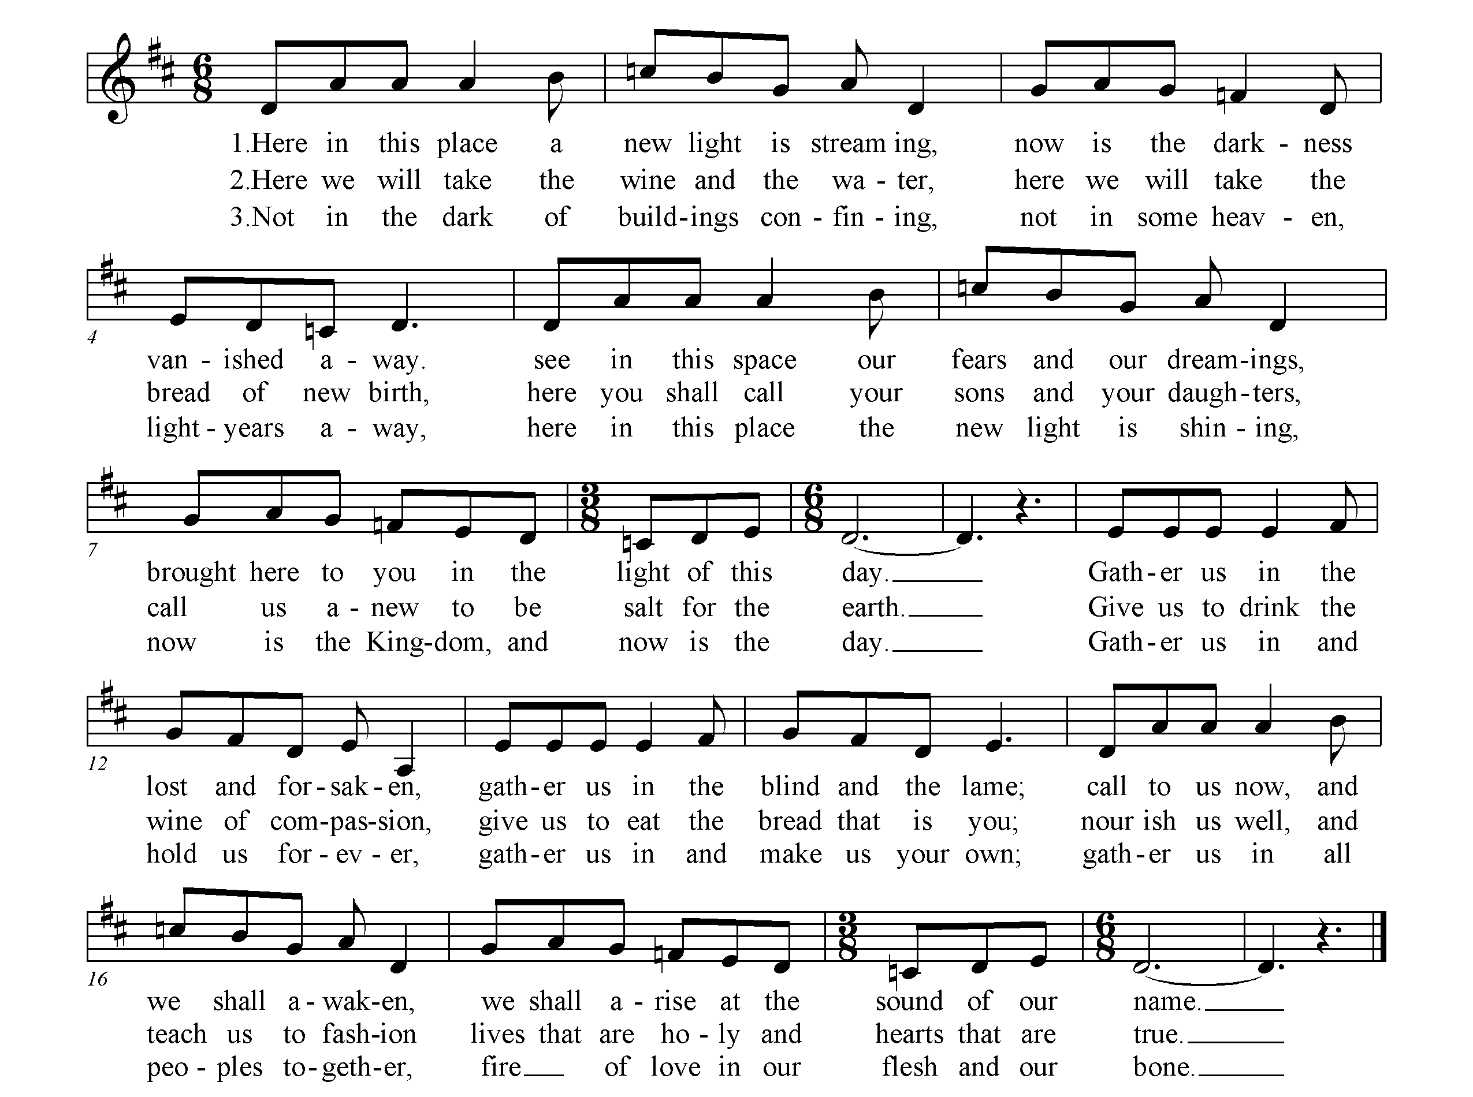

At the asterisk (*), please stand as you are able.

Procession of God’s Light and Word Acolyte: Jan van Amerongen

As the acolyte lights the candle, we remember that Christ is the Light of the world.

Call to Confession
Our loving Creator invites us to confession.
Let us make an honest assessment of our lives so that healing may begin.

Prayer of Confession
Great God: your Son called disciples, and prayed for their unity.
Forgive our divisions and our lack of charity
toward people whose customs are different,
or whose creeds conflict with what we believe.
Forgive our arrogance that insists our way is the only way,
and refuses to consider new possibilities.
Draw the church together in loyalty to our Lord and Savior, Jesus Christ. Amen.

Assurance of God’s Forgiveness
God liberates those who seek forgiveness.
We are free to live as Christ lived.

Response “Know That God is Good”
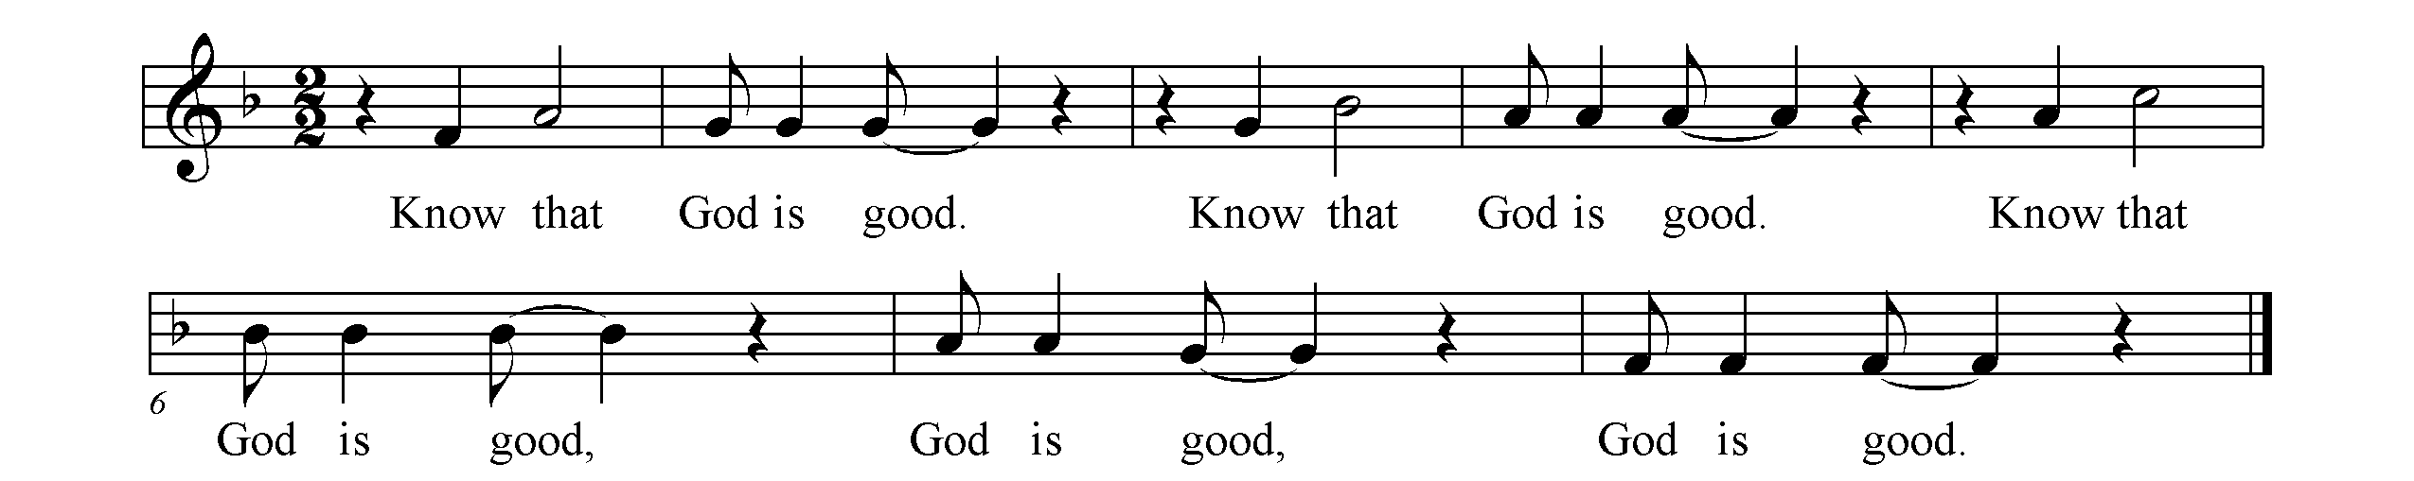

Time With Our Children Greg Jones

Prayer for Illumination Dick Jolly, Lay Liturgist

Scripture Lesson Mark 9:38-50 New Testament, page 39

Sermon “Casting Out Demons” Greg Jones

Offering

During the offering, please sign your name and pass the red folders down each row.
As folders are returned to the center aisle, note the names of fellow worshippers on your pew.

Offertory Anthem “Come, Share the Lord” Bryan Jeffery Leech
Vocal Ensemble

Celebration Of The Lord’s Supper

Invitation to the Lord’s Table

Throughout God’s world this day Christian churches are celebrating the Lord’s Supper
as one family sharing a meal together.
Our sisters and brothers in Europe, Africa, Asia and in all lands,
join us in lifting the bread of life and the cup of salvation.
Nothing shall deter our mission to go forth as disciples
into every city, town and village sharing God’s love.
In Christ our differences are overcome
by a fervent hope for peace throughout our troubled world.

Upon direction, please come forward with your bulletin and gather around the communion table.
You may also feel free to sit on the front pew.

*Hymn “Let Us Break Bread Together” spiritual

*The Great Prayer of Thanksgiving
The Lord be with you.
And also with you.
Lift up your hearts.
We lift them to the Lord.
Eternal God, you create a dynamic universe...

…who forever sing to the glory of your name:

Sanctus
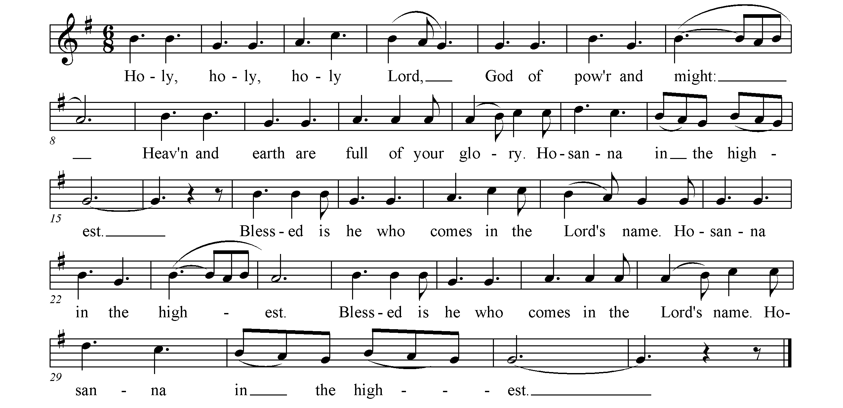



We praise you, most Holy God…
…Great is the mystery of faith:
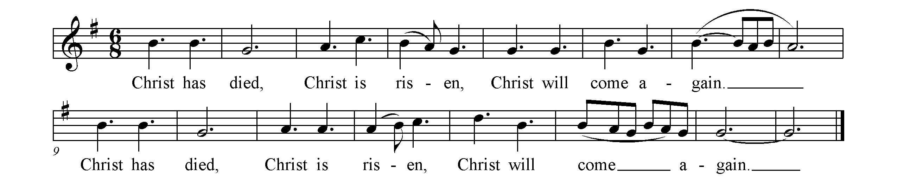



Gracious God…
…all glory and honor are yours, forever and ever:
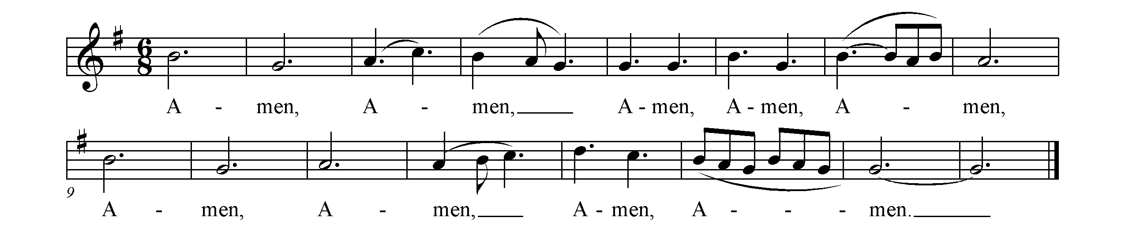


*Lord’s Prayer (page 16 in The Presbyterian Hymnal, using “debts” and “debtors”)

*Words of Institution and Communion of the People

Prayer Following Communion

* Closing Song “As a Fire Is Meant For Burning” beach spring

As a fire is meant for burning with a bright and warming flame,
so the church is meant for mission, giving glory to God's name.
Not to preach our creeds or customs, but to build a bridge of care,
we join hands across the nations, finding neighbors everywhere.

As a green bud in the springtime is a sign of life renewed,
so may we be signs of oneness 'mid earth's peoples, many hued.
As a rainbow lights the heavens when a storm is past and gone,
may our lives reflect the radiance of God's new and glorious dawn.

Words: Ruth Duck © 1992 GIA Publications, Inc.
Used with permission: Onelicense.net #A-715702

*Benediction

Congregational Response (next page)

*Congregational Response “Go Ye, Go Ye into the World”
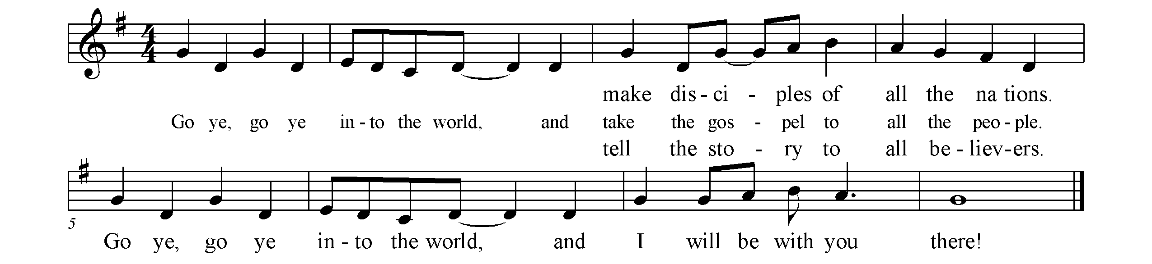

Calendar For the Week
Sunday, October 4 Location
8:15 a.m. Choir Warm-up Adult Music Room
8:30 a.m. Holy Toast Café Community Hall
8:45 a.m. Child Care Cribbery
9:00 a.m. Worship ~ World Communion Sanctuary
9:00 a.m. Godly Play Ruth Christie Room
9:00 a.m. Godly Care for Ages 2, 3 and 4 Under 6 - Classroom A
9:00 a.m. Godly Kids for Grades 3 and 4 Meeting Room
10:10 a.m. Prime Time for Grades 6 thru 8 Classroom 7
10:10 a.m. Workshop Rotation for Grades 1 - 5 Grace Hall
10:10 a.m. Workshop Rotation for Grades 1 - 5 Classrooms 1-4
10:10 a.m. Confirmation Class Classroom 8
10:10 a.m. Adult Ed: Paul's Letter to the Church in Rome Classroom 6
10:10 a.m. Adult Ed: Discovering Joy.... Daughtry House Conf. Room
10:10 a.m. Adult Ed: Westminster By Heart Meeting Room
10:10 a.m. Adult Ed: Parenting Ruth Christie Room
10:10 a.m. Adult Ed: Living Fully Classroom 5
10:10 a.m. Senior High Gathering Library
10:30 a.m. Vocal Ensemble Rehearsal Adult Music Room
11:15 a.m. Worship ~ World Communion Sanctuary
2:00 p.m. Homebound Communion Methodist Country House
3:00 p.m. POLO Picnic Brandywine Creek State Park
4:30 p.m. Youth Choir Kick Off Youth Music Room
5:30 p.m. Dinner Theatre (Dinner~Rehearsal~Set Design) Community Hall, Classroom 6 & Kitchen

Monday, October 5
10:30 a.m. Close Knit Ruth Christie Room
1:15 p.m. Program Staff Rowell Conference Room
5:30 p.m. Rainbow Chorale Music Department

Tuesday, October 6
9:00 a.m. Staff Worship Rodney Chapel
9:30 a.m. Staff Meeting Meeting Room
10:30 a.m. Worship Planning Rowell Conference Room
12:00 p.m. Listening to the Lessons Rowell Conference Room
4:00 p.m. Chapel Chimes Youth Music Room
4:30 p.m. Chapel Club Chapel Club
4:30 p.m. Sunshine Choir Adult Music Room

Wednesday, October 7
6:15 p.m. Reverberations Bell Choir Youth Music Room
7:30 p.m. Westminster Choir Rehearsal Adult Music Room

Thursday, October 8
9:00 a.m. Phix-it Corps Rowell Conference Room
12:00 p.m. Centering Prayer Ruth Christie Room
5:30 p.m. Yoga Rodney Chapel
6:30 p.m. Friendship House Daughtry House Conf. Room
7:00 p.m. Adult Ed - Alan Fox Classroom 6
7:00 p.m. Adult Ed ~ Isaiah Class Rowell Conference Room
7:00 p.m. Pacem in Terris Grace Hall

Friday, October 9
6:00 p.m. Wedding Rehearsal (Ledbetter) Sanctuary

Saturday, October 10
7:30 a.m. Men's Bible Study Club Room
9:00 a.m. Yoga Rodney Chapel
2:00 p.m. Malinowski Wedding Party Ruth Christie Room
3:30 p.m. Wedding Malinowski~Streaser Sanctuary

announcements

Worship Notes

The Chancel flowers today are given to the glory of God and in loving memory of our parents from Bob and Jeanne Checkel.

Sanctuary Flowers - Consider giving the sanctuary flowers for Sunday worship. Your gift of God’s natural beauty to remember or honor loved ones, or to celebrate an event, expresses praise and thanksgiving to God. Please contact Linda Watson during business hours at (302) 571-6719 or lwatson@ycst.com. Available dates for flowers are November 1, 8, 15 and 29.

Are you wearing a nametag? Whether you are a longtime member or new to the church, wearing a nametag provides others the opportunity to meet you, greet you by name, and for you to become more familiar with others at church. Nametags and markers are in baskets at all major entrances. Extend hospitality, kindness and friendship by wearing a nametag every Sunday.

“Westminster to Go” Audio tapes and DVD’s of recent Westminster worship services are available. Please use the sign-out sheet when you borrow them from the front desk. Printed sermons are available on the literature tables the following week and on our website at www.wpc.org.

Congregational Care and Prayer

Please remember in your prayers:

- Those recently hospitalized: Inez Cobb, Richard Franklin, Marty Knepper, Virginia Reichert.

- Westminster’s homebound family who can no longer attend worship with us. Send a card, say a prayer, visit! This week we ask you to remember Louis Frick, HC, and Elva Carty, HC, of Cokesbury Village, 726 Loveville Road, Hockessin, DE 19707 and Kneale Dockstader, 306 Greenbriar Lane, West Grove, PA 19390.

- Our brothers and sisters in worldwide ministry (see back page.)

Westminster’s Covenant Prayer Group is committed to praying weekly for specific needs of the faith community. Anyone with prayer requests may leave a confidential message on (302)654-5848, ext. 335, or fill out a prayer request card (in the pew pocket) and place it in the offering plate.

A Centering Prayer time occurs every Thursday at noon in the Ruth Christie Room. Anyone is welcome to participate. Basically, those who come spend thirty minutes in silence. Silence allows us time and space to empty our minds, quiet our brains’ chatter, and be still and attentive to God.

The wars in Iraq and Afghanistan often seem far away, and we may neglect to realize that Americans, as well as Iraqis, Afghans, and members of coalition forces, continue to die each day. As Christians, we are called to pray for the spreading of peace and justice and an end to violence. If someone in your family is serving in these wars, we ask that you let us know, so that we may include that person on our prayer list. (Contact Colleen Falasco: (302) 654-5214 ext. 131, or cfalasco@wpc.org.)

This week we pray for
- Those known to the WPC Community presently serving in the Middle East:
Afghanistan: Neal Moody, Andy Stoffer and Daniel Reinsenberger
Iraq: Ken Bachman

- The families of those from the U.S. who have died most recently:
Lance Corporal John Malone, age 24, of Yonkers, New York, September 24
Sergeant Titus Reynolds, age 23, of Columbus, Ohio, September 24
Sergeant Edward Smith, age 30, of Homestead, Florida, September 24
Specialist Joseph White, age 21, of Bellevue, Washington, September 24
Top of Form
Lance Corporal Jordan Chrobot, age 24, of Frederick, Maryland, September 26
Specialist Kevin Graham, age 27, of Benton, Kentucky, September 26

- Those who have returned from service, possibly suffering from wounds or Post-Traumatic Stress Disorder, whose scars may by deep and long-lasting.

News to Note
Update on Homeless Sleeping on WPC Grounds
Westminster is committed to many different ministries that provide shelter for the homeless in our community and assistance in their efforts to regain sobriety, employment and independent living. Yet there are still those who resist these ministries and choose instead to camp out on Westminster grounds. Beginning this weekend, we are instituting new security patrols and signage, which will remain in place until the current situation is resolved and will be restored periodically as circumstances require. If you have any questions or concerns, please contact Urban Mission Committee Convener Sue Linderman, (302) 239-7650 or srlinder@dca.net.

What Is ‘Listening To The Lessons’? Each Tuesday at noon, a group gathers in the Rowell Conference Room with the pastor who will be preaching the following Sunday. The pastor leads a discussion of the scripture passage for the upcoming Sunday and the group shares their ideas. “Lessons” are over in a fast-paced hour and you are welcome to bring a brown bag lunch. Each week stands on its own, so you do not have to attend every week.

Do you know where our satellite parking lots are located? We have four additional locations in case you find that the main lot at 13th & Rodney is full: 1508 Penna. Ave. (Directly across from WPC), 1606 Penna. Ave. (Cadillac Dealership – in front), 1611 Penna. Ave. (Boston Market) and behind 1600 Penna. Ave. (access from Clayton Street). As a reminder, help yourself to a map available at the main entrances.

Fellowship
Parents of Little Ones: Families with young children are invited to Brandywine Creek State Park today from 3:00 p.m.-5:00 p.m. Bring a picnic blanket, snacks, drinks and your favorite form of outdoor fun (games, sporting equipment, etc). Entrance to the park is $3 per DE vehicle, $6 per out of state vehicle. We will meet at the picnic tables near the Nature Center/Park Office: 41 Adams Dam Road. See http://www.destateparks.com/park/ brandywine-creek/directions/index.asp for more information and directions.

Yoga in Rodney Chapel
Enjoy an hour of mindfulness as participants are led in breathing and stretching exercises to nurture the connection of mind, body, and spirit. There is no fee, but a $5-$10 donation is appreciated.
Thursdays, 5:30-6:30 p.m. with Christopher Sims / Saturdays, 9:00 – 10:00 a.m. with Mia Muratori

Small Groups
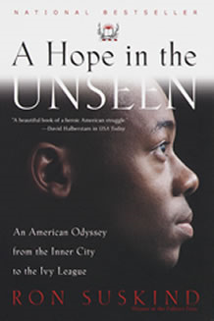 | Girl Talk Continues:  Tuesday, October 27, 7:00 pm, Ruth Christie Room  At Ballou Senior High, a crime-infested school in Washington, D.C., honor students have learned to keep their heads down. Like most inner-city kids, they know that any special attention in a place this dangerous can make you a target of violence. But Cedric Jennings will not swallow his pride, and with unwavering support from his mother, he studies and strives as if his life depends on it--and it does. At Brown University, finding himself far behind most of the other freshmen, Cedric must manage a bewildering array of intellectual and social challenges. Having traveled too far to turn back, Cedric is left to rely on his faith, his intelligence, and his determination to keep alive his hope in the unseen--a future of acceptance and reward that he struggles, each day, to envision.


Our Mission Emphasis for October is “Employment Assistance.”

The uncertainties of the recession have created an employment crisis with rates reaching historic highs. The October emphasis on employment assistance has been designed to help both those in the congregation, as well as those in the broader community, who are out of work, under-employed, or unhappy in their current positions. Those who don’t have current employment issues may want to attend so they can have a better understanding of how to help those who do.

- Next Sunday, October 11, at 10:10 a.m. in Rodney Chapel, we will welcome Mary Davies and Laurie Bick who represent the Community Matters Networking Group (CMNG), a newly established community support group for people in employment transition. Community Matters "addresses the challenges of employment, providing support and the detailed information required for a successful job search. The mission is to build a proactive attitude and apply networking skills to secure employment in the current employment challenges. These efforts bring together specialists in human resource technologies, networking, business and communication with those looking to secure employment."

- On Sunday, October 18, at 10:10 a.m. in Rodney Chapel, we will welcome Darnyelle Jervey, Director of the Center for Women’s Entrepreneurship at the YWCA Delaware. She has the heart of an entrepreneur and the background of a financial services executive. In her current position she works to provide ideas, plans and strategies to help women start their own businesses. Her session at Westminster will help people discover whether they have an entrepreneur within them, and if they do, provide them with the tools and tips to get started. She offers an alternative strategy for those who are out of work.

Please join us for what promise to be two very informative and, possibly, life-changing experiences. For more information, contact Helen Walker (478-9022), Trina Hogan (654-4552) or Steve Tindall (764-1167).

Donate “gently used” children’s shoes for the poor of Guatemala! Member Susan Baddorf will be working with Hearts in Motion in Guatemala this fall. She will take the shoes to children who live in a garbage dump. There is a donation box near the receptionist’s desk and outside of Community Hall through this afternoon.

On Monday, October 5, 2009, in recognition of World Habitat Day, Habitat for Humanity of New Castle County (HFHNCC), in partnership with U.S. Department of Housing and Urban Development, Wilmington Field Office, will address the lack of decent housing around the world, including the need for affordable housing in New Castle County. Focusing on this year’s theme of secure tenure and neighborhood revitalization for hard working families, HFHNCC will host a Groundbreaking Ceremony at 10 a.m. at our newest development, Grace Point, 122 East Lake Street in Middletown. To learn more about World Habitat Day or to get involved with Habitat please contact Brenda Porter-Rockwell at bporterrockwell@habitatncc.org.

Delaware Housing Workshop: Worried about missing a mortgage payment? Facing foreclosure? Suspect a foreclosure scam? Attend a free Delaware Housing Workshop presented by the Attorney General’s Mortgage Fraud Task Force, in conjunction with Delaware State Housing Authority & Office of the State Bank Commissioner:
Wednesday, October 7
New Castle County Government
Gilliam Building
Multipurpose Room
67 Read’s Way
New Castle, DE 19720

Talk with mortgage lenders and servicers – bring your loan information and budget. Also available will be certified housing counselors and representatives from the Attorney Generals Office and other agencies.

Friendship House Job Readiness Volunteers are needed: Volunteer Opportunities are available for computer literacy tutors, Math & English tutors, Job coaches and Computer Lab monitors. Volunteers do not need to be experts, but must have some experience and competency in basic computer or employment skills. Flexible hours, time commitment is as little as two hours twice monthly. Contact: Kathy Graham at (302) 588-7712 or email fhvolunteer.coordinator@verizon.net or come to the orientation program on October 8th at Westminster Presbyterian Church. The session will be held from 6:30 to 8:30 PM in the Daughtry House Conference Room.

The Samaritans are looking for volunteers to help us with pickups and deliveries of furniture. We also need a truck periodically, and if anyone has a truck to loan us that would be a big help. Please call John Bowman at (302) 984-1181 or email him at johnrbowman@comcast.net if you can help.

Greet Scholarship Recipients: The Delaware Technical and Community College students, who are the recipients of the 2009-2010 Educational Talent Search/WPC Scholarship, will attend the 11:15 a.m. service on October 18. The students will be available to meet church members before and after the service. Please take a moment to extend your welcome and encouragement.
“There’s No Place Like Home” Meeting Ground’s 6th Annual Autumn Gathering will be held Saturday, October 24, from 11:00 a.m. to 2:00 p.m. at the Deerfield Golf and Tennis Club in Newark. It will include a buffet luncheon, silent auction and an overview of Meeting Ground’s programs and services. Tickets cost $45/per person and all proceeds support the emergency shelter and transitional housing programs of Meeting Ground assisting those who are experiencing homelessness.
Meeting Ground works “with and among the poor, homeless, the sick, and any who are outcast, living on the margins of society, or those who seek a refuge or a home.” Annually, Meeting Ground provides 30,000+ bed-nights of emergency and transitional housing, as well as 45,000+ meals to the homeless.
 | Help Wanted: Hearts and Hands - It’s time to recruit elves for Westminster’s traditional Christmas Box Project. Tasks are varied; time commitment one to three hours depending on assignment. We need elves to: monitor the donations, shop for last minute gifts, bake cookies, purchase food gift cards, call recipients to remind them when to pick up their box, and distribution elves to serve on December 21st. No experience necessary; training provided; benefits everyone – including you! Contact Sara Geuder at (302) 478-2210 or by e-mail at Geuder@juno.com to sign up. What better way to share the joy of Christmas with those who need more joy in their lives!



Westminster Church Bazaar 2009
Friday, Nov. 6, 1 p.m. – 8 p.m.
Saturday, Nov. 7, 9 a.m. – 2 p.m.

Our annual bazaar is an exciting event for people of all ages in our church and community. All bazaar proceeds are designated for local and global mission outreach efforts which are important to the Westminster congregation.
Now is the time to contact any of the following people to offer gifts of your time and talents. Items to be sold may be delivered to church during set up week. More details can be found on our church literature tables.

White Elephants Barbara Miller
Antiques & Collectibles Carolyn Kleinpeter
Silent Sharing Auction Ellie Furry, Caroline Darling, Kris Qualls

Great bargains also will be found in the book room, children’s department, mission market place, Christmas Shop, and the Bazaar Café.

Please call Susan Williamson or Barbara Clough now to sign on for one of the many times when help is needed. The bazaar requires a very large work force!!

Bazaar Silent Auction
The Silent Auction committee is again seeking items donated by Westminster members. It is now time to start thinking about what you can contribute to make our “sharing” auction a success this year. The possibilities are limitless, but here are a few ideas…
- Donate a special handcrafted item or artwork
- Give tickets to a play, concert or sports event
- Offer a weekend or week at your vacation home
- Cook a special dinner at your home or the recipient’s home
- Offer to wash a car, babysit, petsit, plant bulbs, or rake leaves
- Put together a basket with a theme
- Prepare a special dish or baked good for a future event
- Solicit a donation from a business that you frequent
- Offer tutoring services

Bidding will begin at the preview to be held in Community Hall on Sunday, November 1 between services. All items for the Silent Auction should be submitted by Friday, October 23.

We look forward to hearing from you! Please contact any of the following people with your ideas and donations. Remember that all donated items are tax deductible.

Ellie Furry ejfurry@aol.com 239-4937
Kris Qualls ksqualls1@comcast.net 652-7272
Caroline Darling lymanjr@aol.com 478-0701

Thursday evening Adult Education Classes

Is There Life After Death? – led by Dr. Alan Fox, Professor at UD
Thursday, October 8
7:00 – 9:00 p.m.
Classroom 6
Cost - $5 per session for WPC members

This class will explore the various cultural views of the afterlife with emphasis on the Tibetan Buddhist model. Dr. Fox will also discuss the importance of creating a good death. If the moment of death is the most critical moment of the afterlife, then a good life is understood to be a life that prepares us for that moment, a life that ends in a good death.

Isaiah I, II, and III
Thursdays, October 8 and 29, November 19
7:00 – 8:00 p.m.
Rowell Conference Room

Journey into the depths of ancient prophecy. Engage the Old and New Testaments. All are welcome. Sign-up is helpful, but not required.

Invitation to the New Testament – led by Bob Cox
Thursdays, October 15 – December 17
7:00 – 8:30 p.m.
Meeting Room
Cost - $25 for materials

Developed by Disciple Bible Studies, this short-term 8-week class uses in-depth study of the biblical text, weekly preparation, video mini-lectures, and small group discussion to nurture personal discipleship. Using Matthew’s Gospel as a starting point, this study examines how New Testament writers and the early Christian community wrestled with the implications of the story of Jesus for their lives and their communities of faith.

Pastoral Staff
Gregory K. Jones, Head of Staff
Anne R. Ledbetter, Associate Pastor for Congregational Life

Pastoral Care Assistant: Jill Getty

Church Administrator: Debbie Brown

Church Educator: Susan Moseley

Music Staff
Paul Fleckenstein, Organist/Director of Music
Mary Beth Davis, Director of Music for Children, Youth and Handbells
Sandie Reinicker, Director of Sunshine Choir
Section Leader/Soloists: Diana Milburn, Ruth Bailis, Justin Gonzalez, Brian Carter

Youth Ministry Team
Susan Moseley and Mary Beth Davis

Support Staff
Susan Alexander, Receptionist
Colleen Falasco, Operations Assistant
Jerry Hunter, Financial Assistant
Suzie Hurlock, Administrative Secretary
Nicole Hughes, Director of Communication and Database Management
Jerry Reed, Facilities Manager
Sextons: Roger W. Atkins, Robert King, Kevin Krick, Joan Truitt

Editor of Weekly Word and Chimes: Nikki Thorn

Worldwide Ministry
Malawi – Sue Makin, M.D.
Guatemala – Roger and Gloria Mariott, Dennis and Maribel Smith, Karla Krol and the Mam Presbytery
Congo – Timothee Kalonji Matadi, Cecilé de Sweemer, MD, Pastor Jean-Marc Katujudi Nkuna and
Members of the Kamulumba-Ditalala Parish
Kenya-Rev. Dr. Lyle and Terry Dykstra, PCUSA Mission Volunteers

Session
Liz Bacon, Meg Burich, Martha Carper, Jim Carter, Clark Collins, Charlie Depfer,
Mark Gerstenschlager, Ross Getty, Shelley Gnade, Dick Haden, Denison Hatch, Mary-beth Howard, Fred Iobst,
Barbara Jobe, Don Kuespert, Sue Linderman, Bunny Michener, Jan Patrick, Bruce Petrovick,
Margo Reign, Jerry Spilecki, Alex Sprague, Kathryn van Amerongen, Frank Waldburger

Board of Deacons
Ken Barnaby, Beth Bowersock, Kim Carrick, Jack Coleman, Peggy Carroll, Ginnie Chagnon, Craig Checkel,
Bob Cox, Eadie Churchill, Tammy Daley, Kris DeMesse, Cathy Edge, Eric Etshman, Barbara Fedeler, Todd Gray,
Carol Noggle Harris, Carol Hopkins, Carla Krupanski, Ralph Lewis, David Mathe, Carolyn McKeown, Carol Mosher,
Ruth Nace, Donna Nelson, Polly Pyle-Carter, Teri Richmond, Patti Ridout, Robin Rosser, Ann Shadduck,
Ellen Slade, Cora Sparling, Mike Sprague, Melissa Stabler, Judy Stoffer, Julia Stone, Sally Thomas

Deacon Team of the Month
Donna Nelson, Cathy Edge, Carla Krupanski, Eric Etshman

Trustees
Bob Chagnon, Don Furry, Sara Geuder, John Johnston, George Krupanski,
Bob McKeown, Bill Nace, John Richmond, Christine Schiltz, Stan Stevenson, Philip Timon, Helen Walker

