

Sunday Worship Bulletin

May 31, 2009
Pentecost Sunday

Sunday Worship Bulletin

September 6th, 2009
23rd Sunday in Ordinary Time

Westminster Presbyterian Church extends an enthusiastic welcome, in Christ’s name,
to all who would worship here or join us in fellowship.
We affirm that there can be no exclusion within the body of Christ.

We invite all children of God to join us as disciples of Christ
and participate fully in the life of our congregation.

1502 West 13th Street · Wilmington, DE 19806
302-654-5214 · Fax: 302-654-5706 · www.wpc.org

Welcome to Westminster

Whether you are worshiping at Westminster for the first time or returning for a visit,
we sincerely welcome you in the name of Christ!

We welcome to the pulpit this morning Evans Presley-McGowan, a student at San Francisco Theological Seminary, currently working as an intern at First Presbyterian Church in Berkeley, California. Evans is a member of Westminster Presbyterian Church, under the care of Westminster’s Session, and the son of Anne Ledbetter and Keith McGowan. Emily Presley-McGowan, Evans’ wife, is beginning her studies at Pacific School of Religion in Berkeley.

- Following our 10:00 a.m. worship service, we invite you to meet today’s “ambassador,” Anne Gunn, at the back of the sanctuary. She will have a gift for you, and can share information regarding our many ministries for children, youth and adults. She can also guide you to the hospitality area to enjoy fellowship or lead you on a tour of the church.

- Children are welcome in worship! Westminster’s Kids’ Notes and worship bags are available each Sunday from the ushers. Kids’ Notes, a weekly companion to Westminster’s morning worship, emphasizes listening and seeing during worship. The bags include storybooks for children of all ages, coloring paper and crayons, a children’s bulletin for those age three to six, and bookmarks for hymns and Scripture.

- Worship Aids - Large print Presbyterian Hymnals and hearing devices may be obtained from any usher.

- Would you like to know more? Check out our new website at www.wpc.org.

Today’s Schedule

9:45 – 11:15 a.m. Child Care for Cribbery (birth – toddler)

10:00 a.m. Worship Service in the Sanctuary

10:00 a.m. Sunday School for Under Six in the Under-Six Classrooms

11:00 a.m. Summer Tea on the Church Lawn

Sunday Morning Schedule Beginning September 13

8:45 – Noon Child Care for Cribbery (birth – toddler)

9:00 a.m. Traditional Worship Service with Westminster Choir and organ

- After Time With Our Children, if you wish, your children may
leave the Sanctuary and go to:

Godly Care-An unique opportunity for children ages 2 - 4 to get to know God through music, crafts, prayers and stories. Classes are in the Under-Six Classrooms A & B.

Godly Play-Children in kindergarten through second grade gather in the Ruth Christie Room to learn the language of God’s people through sacred space, stories, parables and liturgical actions.

Godly Kids-Worship education for children in grades 3 and 4 in
the Meeting Room. Godly Kids return to the sanctuary during the final hymn and sit together until their parents meet them following the postlude.

10:10 a.m. Sept. 13th - Christian Education Open House for all ages in Community Hall
Beginning Sept. 20th - Prime Time Education Hour for all ages.

11:15 a.m. Worship with old hymns, new songs, and creative liturgy.
Children are always very welcome in worship.
Childcare is also available in Under-Six for ages 2 – Grade 2.

Hospitality and Fellowship
The Holy Toast Café, located in Community Hall, open from 8:30 a.m. to 11:15 a.m.
Coffee and fellowship are free. A variety of breakfast foods is available for one dollar per item.

ORDER OF WORSHIP AT 10:00 A.M.

Preparation for Worship
“Sifting measuring pouring mixing, kneading rising baking breaking: the choreography of feeding is as common as our common lives, common sensing, common sharing. common is as common does, common loaf bears revelation, common crust can feed us all.”
Comm(on)union, by Jan L. Richardson

Organ Prelude Prelude in Classic Style Gordon Young

Welcome and Announcements

*Passing of the Peace

*Call to Worship
We come together to thank the Creator of life.
We come to praise God’s holy name and to seek God’s ways.
We come to be forgiven and to forgive.
We come to be a community in God’s love.
We come, in short, to worship,.
Let us praise God!

*Hymn No. 466 “O for a Thousand Tongues to Sing” AZMON

Call to Confession

Prayer of Confession
Loving God, forgive us.
We wrap our days in a shroud of busy routine that protects us from the rigors of what we believe.
Our families are left too often lonely;
Our neighbors are left too often in need of a friend;
Our community is left to often in need of truth; and
Your church is left too often in need of servants.
Interrupt us with the gospel of Jesus Christ that our days may be filled with the world of faithfulness. We pray in the name of Christ.

Silent Prayer

Assurance of Forgiveness
The mercy of God is from everlasting to everlasting.
As far as the east is from the west,
so far does God remove our transgressions from us.
I declare unto you in the name of Christ we are forgiven.
And let God’s forgiven people say:
Amen.

At the asterisk (*), please stand as you are able.
Passages in bold print may be said by all.

Time with our Children Susan Moseley

Prayer for Illumination

Scripture Readings Proverbs 22:1-2, 8-9, 22-23 Dede Johnston, Lay Liturgist
Mark 7:24-30 Pages 566 and 37

Sermon “Who’s Under the Table?” Evans Presley-McGowan

Offering
During the offering, please sign your name and pass the red folders down each row.
As folders are returned to the center aisle, note the names of fellow worshippers on your pew.

Offertory Murmelndes Lüftchen Adolf Jensen
(Murmuring Zephyrs)

The Sacrament of the Lord’s Supper

Invitation

*Hymn No. 507 “I Come with Joy” DOVE OF PEACE

The Great Prayer of Thanksgiving
The Lord be with you,
And also with you.
Lift up your hearts;
We lift them to the Lord.
Eternal God…

Communion of the People

Prayer following Communion

Lord Jesus Christ, you have put your life into our hands; now we put our lives into yours. Take us, renew and remake us. What we have been is past; what we shall be, through you, still awaits us. Lead us on. Take us with you. Amen.

*Hymn No. 421 “The Church of Christ in Every Age” WAREHAM

Benediction

Organ Postlude Verbum Supernum Marcel Dupré

*Going Forth

If you are visiting with us for the first time, we invite you to meet today’s ambassador,
Anne Gunn, at the baptismal font at the rear of the sanctuary.

You are invited for Summer Tea on the Church Lawn.
announcements

Worship Notes

The flowers in the sanctuary are given to the glory of God and in memory of military personnel who gave their lives for our freedom by several thankful members.

The rosebud at the side of the pulpit this morning is in celebration of the birth of Adam Jeffrey Briggs, born August 26, son of Jacy and Mike Briggs and sister to Molly Anne. He is the grandson of Jeff and Janet Kline and great-grandson of Bob Kline. We welcome this child into the Westminster family.

Sanctuary Flowers - Consider giving the sanctuary flowers for Sunday worship. Your gift of God’s natural beauty to remember or honor loved ones, or to celebrate an event, expresses praise and thanksgiving to God. Please contact Linda Watson during business hours at 302-571-6719 or lwatson@ycst.com. Available date for flowers is
September 27.

Are you wearing a nametag? Whether you are a longtime member or new to Westminster, wearing a nametag provides others the opportunity to meet you, greet you by name, and for you to become more familiar with others at church. Nametags and markers are in baskets at all entrances. Extend hospitality, kindness and friendship by wearing a nametag each Sunday.

“Westminster to Go” Audio tapes and DVD’s of recent Westminster worship services are available. Please use the sign-out sheet when you borrow them from the front desk. Printed sermons are available on the literature tables the following week and on our website at www.wpc.org.

Congregational Care and Prayer

Please remember in your prayers:

- Westminster’s homebound family who can no longer attend worship with us. Send a card, say a prayer, visit! This week we ask you to remember Mrs. Grace Austin, Apt.3613 and Mrs. Edie Lennox, HC3968, Methodist Country House, 4830 Kennett Pike, Wilmington, DE 19807.

- Our brothers and sisters in worldwide ministry (see back page).

Westminster’s Covenant Prayer Group is committed to praying weekly for specific needs of the faith community. Anyone with prayer requests may leave a confidential message on 302-654-5848, ext. 335, or fill out a prayer request card (in the pew pocket) and place it in the offering plate.

The wars in Iraq and Afghanistan often seem far away, and we may neglect to realize that Americans, as well as Iraqis, Afghans, and members of coalition forces, continue to die each day. As Christians, we are called to pray for the spreading of peace and justice and an end to violence. If someone in your family is serving in these wars, we ask that you let us know so that we may include that person on our prayer list. (Contact Suzie Hurlock: 302-654-5214 ext. 131, or suzie@wpc.org).

This week we pray for:

- Those known to the Westminster community presently serving in the Middle East:
Afghanistan: Neal Moody, Andy Stoffer and Daniel Reinsenberger
Iraq: Ken Bachman and Beau Biden

- The families of those from the U.S. who have died most recently:
Private 1st Class Eric Hario, age 19, of Monroe, Michigan, August 28
Sergeant Earl Werner, age 38, of Mondovi, Wisconsin, August 28
Private Taylor Marks, age 19, of Monmouth, Oregon, August 28
Private 1st Class Mathew Wildes, age 18, of Hammond, Louisiana, August 27
Staff Sergeant Kurt Curtiss, age 27, of Murray, Utah, August 27
Lance Corporal Donald Hogan, age 20, of San Clemente, California, August 26
Private 1st Class Dennis Williams, age 24, of Federal Way, Washington, August 24
Sergeant 1st Class Ronald Sawyer, age 38, of Trenton, Missouri, August 24
Captain Cory Jenkins, age 28, of Mesa, Arizona, August 24
Captain John Hallett III, age 30, of California, August 24

- Those who have returned from service, possibly suffering from wounds or Post-Traumatic Stress Disorder, whose scars may be deep and long-lasting.

News To Note

The deadline for the Sunday bulletin and the “Westminster Weekly Word” is Tuesday at 2:00 p.m. Send announcements and articles for either of the publications to news@wpc.org.

Calling all Muffin Ministers! The Holy Toast Café reopens next Sunday, and we need volunteers to bake 2-3 dozen muffins on a given Sunday. The congregation enjoyed a wide variety of sumptuous muffins last year and many folks are eagerly anticipating the return of their favorite blueberry or bran muffin! Rogers Atkins is coordinating the volunteers so contact him if you’d like to be bake muffins one or more Sundays. His email address is ratkins1955@aol.com

Please give some thought and prayer as to whom among our church family would be good nominations for Deacon, Elder and Trustee. You may email or call your suggestions to Bunny Michener at bunnymichener@comcast.net, 302-478-4224 or Dick Haden at jrhaden@msn.com, 610-459-0270.

Oberammergau Passion Play Join Sara Geuder for a guided trip to southern Germany beginning and ending in Munich, June 1-9, 2010, including the Passion Play, which is presented only once every ten years in Oberammergau. The group is limited to a maximum of 12 people, and must have commitments from at least ten. Visit www.pilgrimtours.com/groups/geudergroup.htm or contact Sara Geuder (302-478-2210) geuder@juno.com for more information. Sara planned this excursion as a possible extension to the Westminster Choir Germany Tour; however, you may simply register for the Oberammergau trip alone.

Wholeness in Body and Spirit

HealthySteps is an exercise program to improve mobility and quality of life for cancer survivors and those with chronic immune disorders. There will be a free, introductory class on September 11, from 9-10:00 a.m., at Trinity Presbyterian Church on Naamans Road in Wilmington. The class will regularly meet on Friday mornings. Please call the instructor, Joy Mulholland, at 397-1134 for class details. See www.gohealthysteps.com for information on the program.

Saturday morning yoga returns at 9 a.m. next Saturday, as we begin another season at Westminster. Classes run for one hour. It is a fabulous way to begin your weekend or end a busy workweek. All ages and ability levels are welcome. It is a free-will offering – suggested donations of $5-$10. Questions? Email Robin Rosser at rlrossser@aol.com or Anne Ledbetter at anne@wpc.org

Adult Education and Small Groups

If you are interested in joining or learning more about our church, we invite you to attend the New Member Class on next Sunday from 10:00 – 11:00 a.m. in Classroom 5, (downstairs across from Community Hall). For more information, contact Anne Ledbetter, 654-5214, ext. 124, or anne@wpc.org

Grief is an arduous journey, and it can often be a lonely one. For 12 weeks this fall, Rev. Anne Ledbetter will be leading a grief education and support group using the resource Understanding Your Grief. Through reading, journaling, and group discussion participants will take steps in learning about the grief process, understanding their personal experience of grief, and supporting one another on the journey. The registration fee for this group is $30 to cover materials. Please contact Anne (654-5214, ext. 124) if you are interested in participating in this group which will meet Sunday afternoons, 5:00 – 6:30 p.m., from September 20 – December 6.

Be a Part of Westminster By Heart, a group whose purpose is to develop tellers who will present scripture in our worship services each month. We will meet during the Education Hour beginning September 20th to learn some techniques for this biblical discipline and to learn these stories together. Westminster By Heart will provide a unique opportunity to study scriptures, foster a deeper connection to Biblical stories, and develop skills for telling Scripture in worship. If you have an interest, contact Shelly Gnade (302-778-5101) or Mary-beth Howard (302-654-1783) or email to gnade_s@msn.com

New for 2009 – Long-term exploration of Isaiah I, II and III, one of the major prophets. Beginners and scholars are welcome to gather twice a month on Thursdays 7:00-8:00 p.m., September 24 through June, to develop a deeper understanding of this Old Testament book so frequently referenced in the New Testament. Babs Harris will convene the sessions. Please contact Babs directly (302-325-9094) if you are interested in registering for this study.



Our Mission Emphasis for September is “Serving Others.”

Mark your calendars for our Mission Fair on Sunday mornings, September 20 and 27, as we honor Chad Miller's ministry with us and share information on the many ways Westminster dedicates our time, talent and treasure to serving others. Come to Community Hall and learn how your generous contributions are making a difference in our community and our world - you'll be so glad you did!

Our Summer Guatemala Youth Mission Team will host a luncheon on Sunday, September 20th, at 12:15 p.m. to share their experiences with the congregation. If you are already a “shareholder” in the trip, then you already have a reservation. Others may purchase a ticket/share in the trip by calling the church office for a reservation, or stopping by the 180° Youth Ministry table at the Christian Education Fair next Sunday, September 13. Shares are available in $20.00 increments. Reservations are due by Thursday, September 17th. Plan to attend this luncheon and hear how the lives of our youth and their adult leaders were changed as a result of this experience.

'Girl Talk' Continues: Our summer reading program was a great success! All involved would like to continue these gatherings and discussions now that autumn is near. We are working on the details for the full program year, but wanted to be sure you mark your calendar for Thursday, September 24, when we will gather at 7:00 pm at Anne Ledbetter's home for a discussion of Olive Kitteridge. Please RSVP to Anne (654-5214, ext. 124 or anne@wpc.org) if you plan to attend - and feel free to bring a snack to share.

Help Wanted: Lutheran Community Services needs a part-time assistant program director to help families in crisis with food, housing and utility assistance at our LCS FAITH Center location (3rd and Walnut Streets, Wilmington). Seeking a caring individual with degree in human service field and/or social service experience. Bi-lingual a plus. Send resume and cover letter by 10/31 to LCS, 1304 N Rodney St. Wilmington, DE 19806 or email info@lcsde.org.

Friendly’s Restaurant on Kirkwood Highway is hosting a Family Promise night this Wednesday, September 16 from 5:00 to 9:00 p.m. 10% of all sales go to Family Promise. (Westminster is one of 13 host churches sponsoring this organization, which shelters and feeds local homeless families in our own church building.) Pick up a “FREE” ticket at the receptionist desk, or just let the greeter at Friendly’s know that you are with Westminster Presbyterian Church in Wilmington. All 13 churches will be participating. Let’s see if Westminster can have the largest turnout!

We need two more computer mentors for the second computer literacy class for residents in Burton and Daughtry Houses, beginning in early September. The course consists of eight 90-minute evening sessions at Daughtry House. We have developed a written teaching plan that covers computer basics: the Internet, e-mail, Microsoft Word and Excel, and keyboarding. The course is geared to online job applications, writing résumés and enhancing employability. Call Jim Clark @ 996-0406 for more information.

The Gulf Coast still needs us to help in the rebuilding. Join your fellow Westminster members in New Orleans for a week of fulfilling Habitat work and fellowship. We will be hosted again by St. Charles Avenue Presbyterian Church through their RHINO projects. Accommodations are a bit more posh than past trips, as participants will be staying at Brent House, a residence hotel. Act now – there are openings in the next trip which will be November 16-22. Contact Liz Bacon at (302) 658-8419 or elizabeth.bacon@comcast.net to reserve your spot.

Calendar for the Week

Sunday, September 6 Location
9:45 a.m. Child Care Cribbery
10:00 a.m. Worship with Communion Sanctuary
10:00 a.m. Sunday School Under Six Under Six Classroom D
11:00 a.m. Summer Tea Church Lawn
11:00 a.m. Stephen Ministry Rowell Conference Room
1:00 p.m. Homebound Communion Rowell Conference Room

Monday, September 7 Church Offices Closed

Tuesday, September 8 Location
9:30 a.m. Staff Meeting Rowell Conference Room
10:00 a.m. Mental Health Support Group Club Room
10:30 a.m. Worship Planning Rowell Conference Room
5:30 p.m. BPI Daughtry House Conf. Room
7:00 p.m. Chapel Club Staff Meeting Rowell Conference Room

Wednesday, September 9 Location
8:00 a.m. Department of Education Community Hall
6:30 p.m. Nominating Meeting Rowell Conference room
7:00 p.m. Mental Health Support Group Club Room
7:30 p.m. Westminster Choir Rehearsal Adult Music Room

Thursday, September 10 Location
12:00 p.m. Women’s Depression Support Group Classroom 5
5:30 p.m. Yoga Rodney Chapel
6:30 p.m. Teen Parenting Class Classroom 7
8:00 p.m. AA Club Room

Friday, September 11 Location
6:00 p.m. Recovery on the West Side - NA Classroom 5
9:30 p.m. AA Club Room

Saturday, September 12 Location
7:30 a.m. Men’s Bible Study Club Room
9:00 a.m. Yoga Rodney Chapel
6:00 p.m. Emily Iobst ~ Travis Crawford wedding Sanctuary


180˚ Imago Dei: Youth Ministry at WPC
Join us this program year as we look inward at our self-image and how we reflect “Imago Dei,”
the image of God, to ourselves, our peers, our families and our community. Get all the details AND dessert on Sunday, September 13!

“Details and Dessert” Sunday, September 13 Classroom 6
Everything you need to know about 180° Imago Dei
for youth in grades 7 – 12 and their parents.
6:30 – 7:45 p.m.

************************************************************************

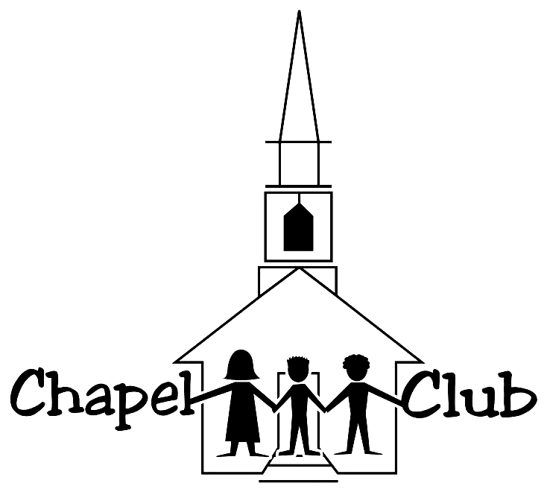
Got Tuesdays???

Chapel Club begins on Tuesday September 15! Have your registered your 3rd – 6th grader? If not contact Jeanne Checkel at jeannecheckel@hotmail.com.

NEW to Chapel Club this year: Wacky and whimsical games and an earlier ending time!

Join the fun each Tuesday from
4:30 – 7:00 p.m.!!!

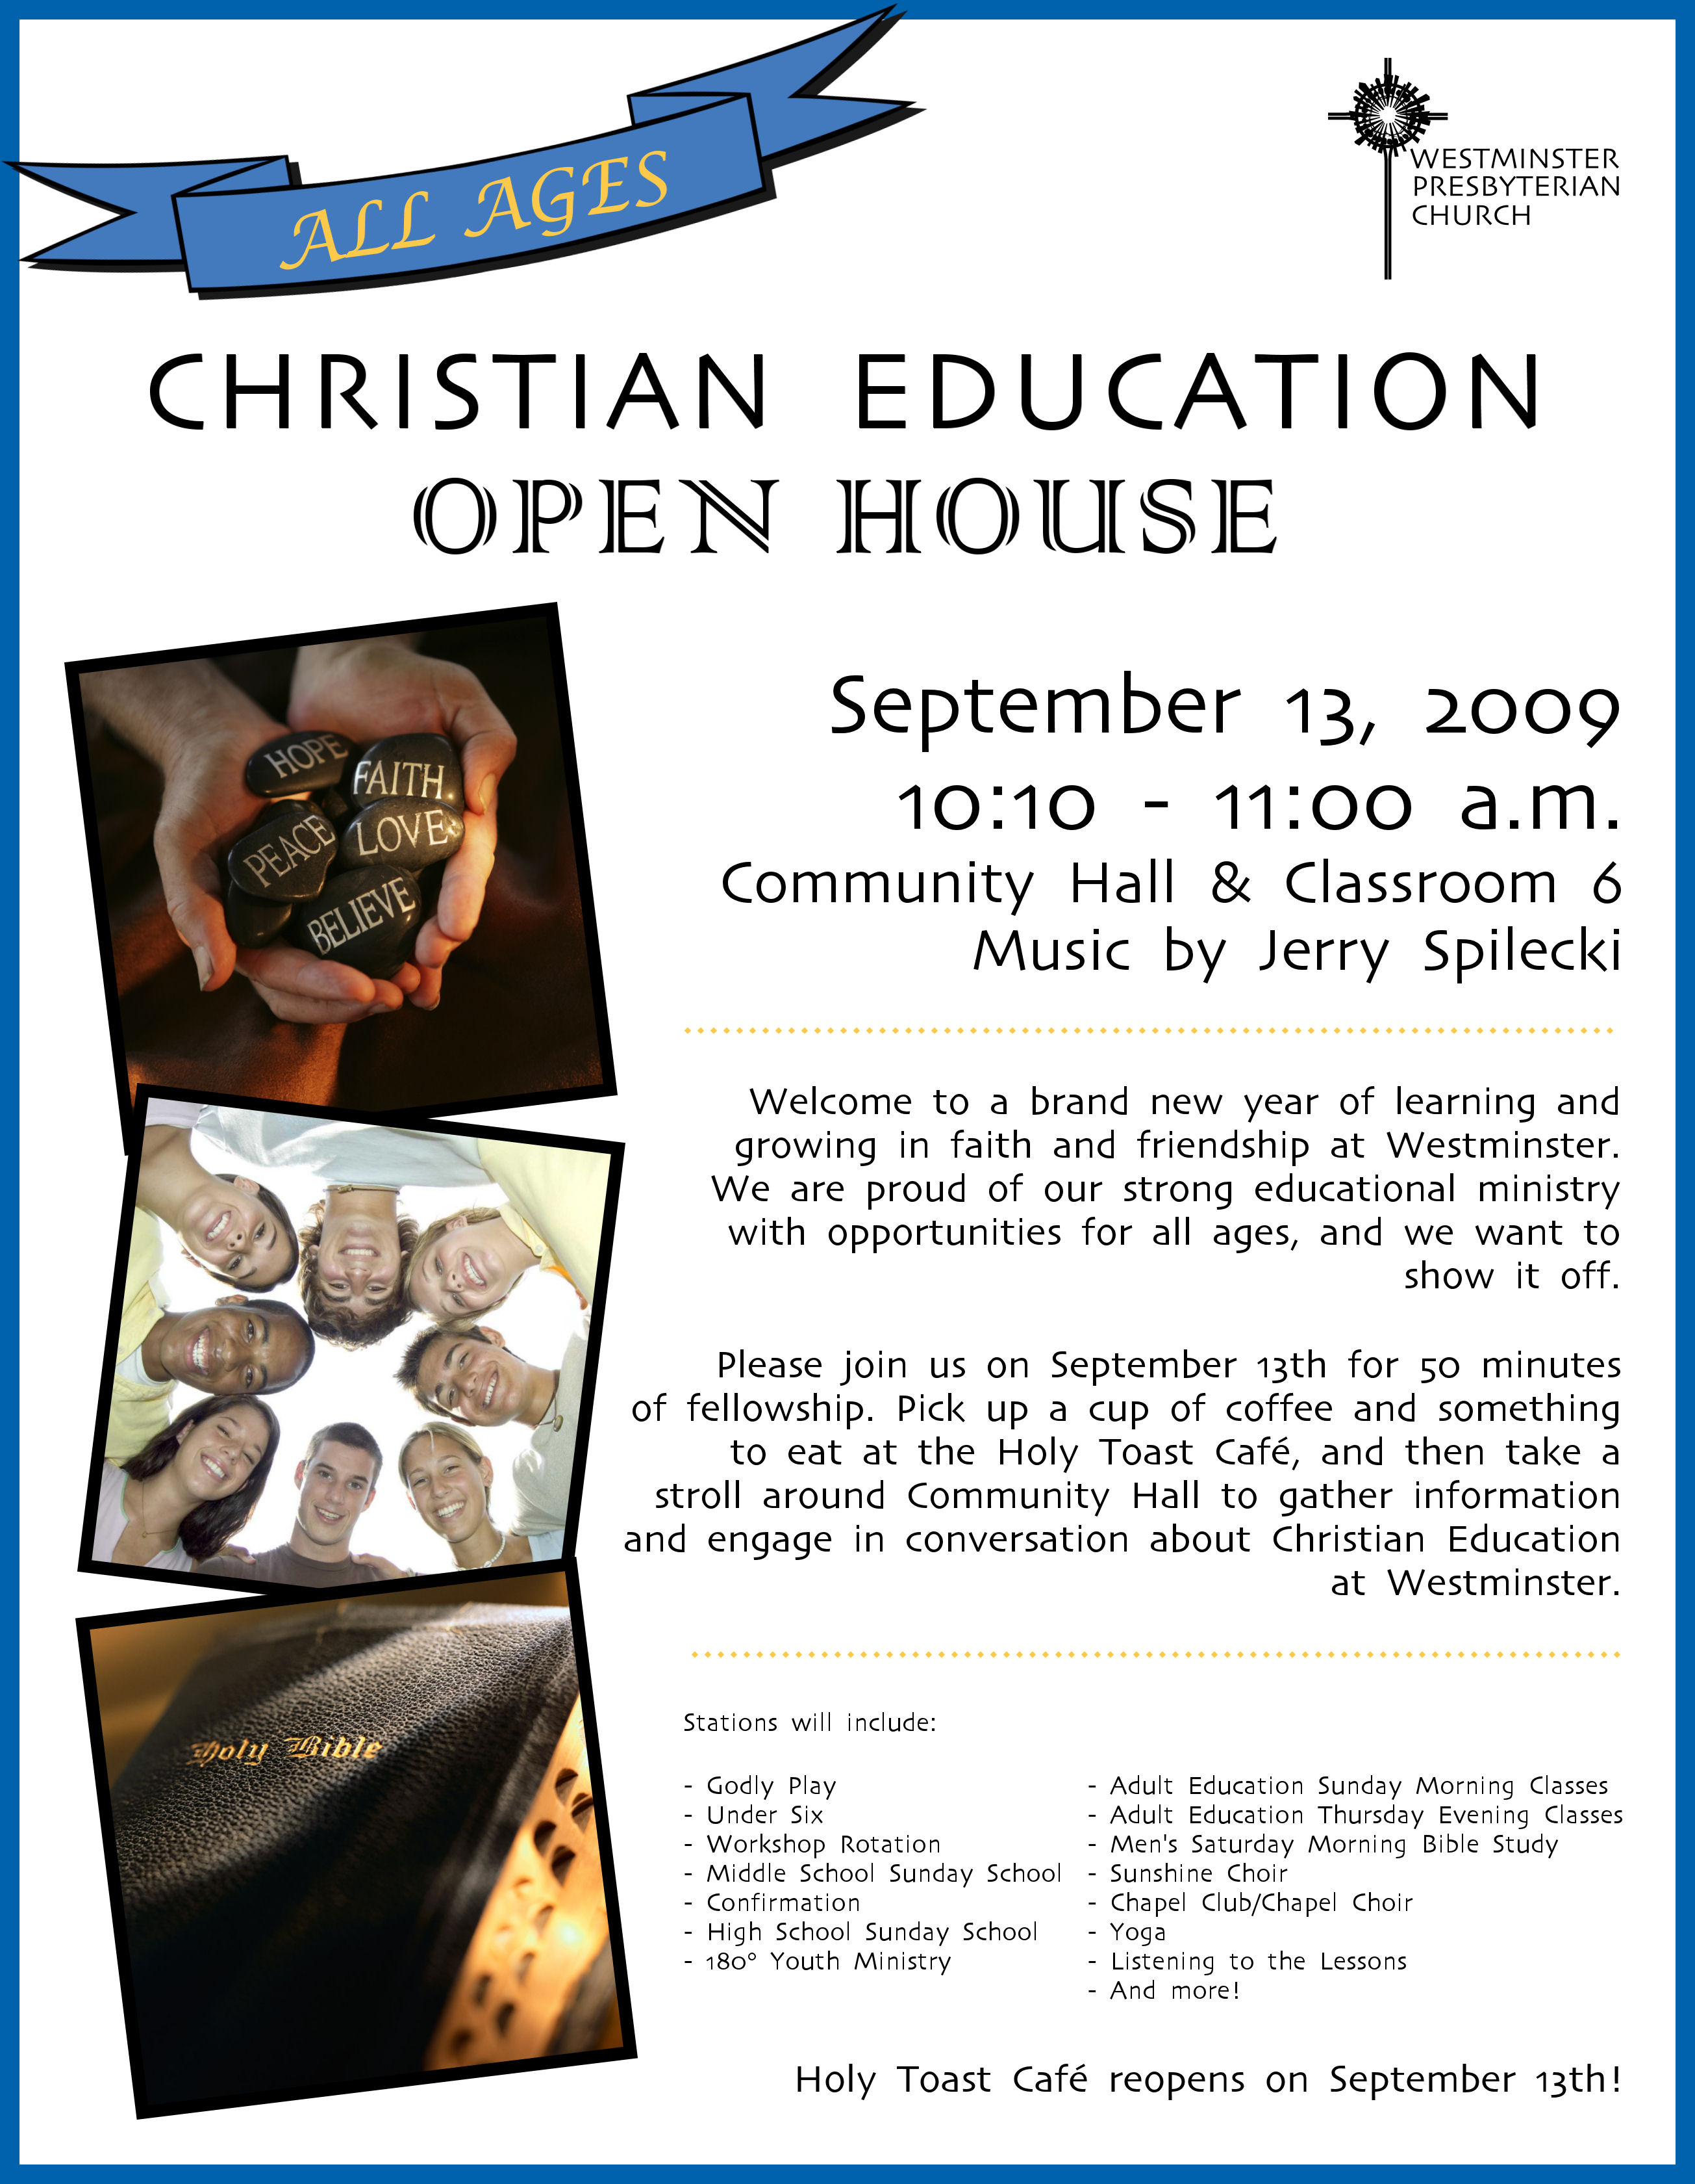

Pastoral Staff
Gregory K. Jones, Head of Staff
Anne R. Ledbetter, Associate Pastor for Congregational Life

Pastoral Care Assistant: Jill Getty

Church Administrator: Debbie Brown

Church Educator: Susan Moseley

Music Staff
Paul Fleckenstein, Organist/Director of Music
Mary Beth Davis, Director of Music for Children, Youth and Handbells
Sandie Reinicker, Director of Sunshine Choir

Youth Ministry Team
Susan Moseley and Mary Beth Davis

Support Staff
Susan Alexander, Receptionist
Colleen Falasco, Operations Assistant
Jerry Hunter, Financial Assistant
Suzie Hurlock, Administrative Secretary
Nicole Hughes, Director of Communication and Database Management
Jerry Reed, Facilities Manager
Sextons: Roger W. Atkins, Robert King, Kevin Krick, Joan Truitt

Editor of Weekly Word and Chimes: Nikki Thorn

Worldwide Ministry
Malawi – Sue Makin, M.D.
Guatemala – Roger and Gloria Mariott, Dennis and Maribel Smith and the Mam Presbytery
Congo – Timothee Kalonji Matadi, Cecilé de Sweemer, MD, Pastor Jean-Marc Katujudi Nkuna and
Members of the Kamulumba-Ditalala Parish
Kenya-Rev. Dr. Lyle and Terry Dykstra, PCUSA Mission Volunteers

Session
Liz Bacon, Meg Burich, Martha Carper, Jim Carter, Clark Collins, Charlie Depfer,
Mark Gerstenschlager, Ross Getty, Shelley Gnade, Dick Haden, Denison Hatch, Mary-beth Howard, Fred Iobst,
Barbara Jobe, Don Kuespert, Sue Linderman, Bunny Michener, Jan Patrick, Bruce Petrovick,
Margo Reign, Jerry Spilecki, Alex Sprague, Kathryn van Amerongen, Frank Waldburger

Board of Deacons
Ken Barnaby, Beth Bowersock, Kim Carrick, Jack Coleman, Peggy Carroll, Ginnie Chagnon, Craig Checkel,
Bob Cox, Eadie Churchill, Tammy Daley, Kris DeMesse, Cathy Edge, Eric Etshman, Barbara Fedeler, Todd Gray,
Carol Noggle Harris, Carol Hopkins, Carla Krupanski, Ralph Lewis, David Mathe, Carolyn McKeown, Carol Mosher,
Ruth Nace, Donna Nelson, Polly Pyle-Carter, Teri Richmond, Patti Ridout, Robin Rosser, Ann Shadduck,
Ellen Slade, Cora Sparling, Mike Sprague, Melissa Stabler, Judy Stoffer, Julia Stone, Sally Thomas

Deacon Team of the Month
Carol Mosher, Kim Carrick, Melissa Stabler, Carla Krupanski

Trustees
Bob Chagnon, Don Furry, Sara Geuder, John Johnston, George Krupanski,
Bob McKeown, Bill Nace, John Richmond, Christine Schiltz, Stan Stevenson, Philip Timon, Helen Walker

