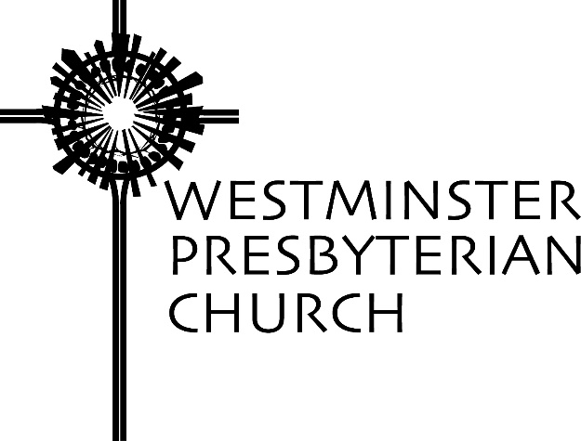

“Breaking Barriers”
Scripture – John 5:1-9
Sermon preached by Gregory Knox Jones
Sunday, May 26, 2019

Many of us know the story of Roger Bannister. He was a medical student in England who also happened to be a wicked fast middle distance runner. After finishing fourth in the 1500 meters in the 1952 Helsinki Olympics, he set his sights on becoming the first human to run a mile in less than four minutes. At the time, it was believed to be impossible.

However, on May 6th, 1954 in Oxford, England, Bannister stepped onto the track feeling confident. Then he did what people believed was unattainable. He broke the four minute barrier. Do you know how long his record stood? Forty-six days.

Once it was no longer deemed preposterous, others began to break the four minute barrier. Within one year of Bannister’s accomplishment, 37 other runners ran faster than four minutes. The next year, 300 runners broke the so-called impossible barrier!

How often are we constrained by boundaries that are not as fixed as we imagine? What mental barriers reside in each of us that prevent us from attaining what we label “impossible?” What unconscious roadblocks have you erected in your mind?

On a day when the temperature is predicted to be in the upper 80s, it’s appropriate that today’s scripture reading takes us poolside. Jesus has ventured into Jerusalem and walked to the Pool of Bethesda. Our text informs us that this pool has five porticoes and in them “lay many people who are blind, lame, and paralyzed.”

Before actually seeing it, I had pictured the Pool of Bethesda to be about the size of a modest backyard swimming pool with a dozen or so people around its edges. Was I ever mistaken! Ten years ago, when I first laid eyes on its ruins, I was stunned to see how enormous the pool was – roughly the length and width of a football field. So when Jesus visited it, there may have been a few hundred people there.

The huge pool was fed by an underground spring that would occasionally create bubbling in the water. Legend claimed that this bubbling was actually an angel stirring the water and the first one in the pool after the stirring was miraculously healed.

I smile when I imagine the wild scene each time those waters rippled. A mass of humanity diving in all at once, water spraying everywhere!

Our text says that Jesus zeroed in on one particular man at the pool’s edge, a man who had been ill for 38 years. Jesus approached the man and asked, “Do you want to be made well?”

At first glance, it appears a bit embarrassing to hear Jesus ask such a question. We might even anticipate the man replying sarcastically, “No, I don’t want to be made well, I’m just out here to catch a few rays!”

However, the man says, “Sir, I have no one to put me into the pool when the water is stirred up; and while I am making my way, someone else steps down ahead of me.”

I confess the man’s words immediately punch all of my pastoral buttons. I want to lend a sympathetic ear to the poor fellow’s predicament. I want to patiently listen to him as he pours out his plight, thoughtfully nodding, letting him know I feel his pain. I want to reach out and touch his arm and say, “You poor man. I can’t imagine your agony.”

That’s the compassionate thing to do, right? Give the man an opportunity to tell his story and express his pain. Let him know someone truly cares. That should prompt a modicum of psychological relief. It would not make him well, but it would temporarily alleviate his anguish.

However, this is not how Jesus responds. After the man explains to Jesus that others always beat him into the water, Jesus replies with a curt response: “Stand up, take your mat and walk!” It sounds as if Jesus has morphed into a drill sergeant. Why the stern response?

Apparently, the question Jesus asked earlier was not so ludicrous. When he asked, “Do you want to be made well?” he was pushing the man to honestly consider whether he wanted to break a 38 year pattern of seeing himself and being seen by the world as a tragic figure. For 38 years he had received the sympathy of others. Was he really ready to give that up?

Do you want to be made well? Debi Thomas says that for her, “the question stings because she knows exactly what it’s like to say I want out, I want freedom, I want healing – but not quite mean it. She knows what it’s like to cling to brokenness simply because it’s familiar; what it’s like to make victimhood her identity, what it’s like to benefit from the very things that cause her harm, what it’s like to sink into self-pity, what it’s like to assume that everyone else has access to a magic pill she will never get her hands on. She knows what it’s like to decide that she’s doomed to sit at the very edge of healing for the rest of her life, but never attain it.”¹

When Jesus called for the liberation of the oppressed, his primary focus was on freeing people from an oppressive government or oppressive poverty. However, Jesus also wants to free us from the constraints we put on ourselves – the invisible chains we have wrapped around ourselves preventing us from breaking out of a negative mindset or a harmful behavior.

Many times lending a sympathetic ear is precisely what someone needs. A woman who is currently slogging her way through the valley of the shadow of death needs a hand in navigating the stages of grief. A compassionate listener can aid the process.

However, sometimes people become stuck. They have a host of good reasons to explain their predicament and defend their actions, but they are stuck. They do not need a compassionate ear. They need a loving push to break the artificial barrier they have created in their mind.

Do you want to get well? Yes, but what can you expect from someone in my condition? Do you want to get well? Yes, but I’m too old to learn something new. Do you want to get well? Yes, but that bleeping jerk cut in front of me. Do you want to get well? Yes, but first I need to buy the latest model. Do you want to get well? Yes, but first she has to say she’s sorry. Do you want to get well? Yes, but I cannot go on without her. Do you want to get well? Yes, but you don’t understand what it’s like to be – fill in the blank.

Many of us have great difficulty breaking through the barriers we have created in our minds. Like the man at the Pool of Bethesda, we can list convincing reasons for being in our current predicament. Even though we are not in a healthy place, we are in a familiar place. We know how to endure our unhealthy place. We fear stepping into unfamiliar territory.

Life continually presents us with new possibilities and God wants us to embrace what is beautiful and life-enriching and advances the common good. I wonder how many opportunities we sidestep without even giving them a second thought. I wonder how many times we reject a promising prospect because we do not believe we are up to the challenge. How many times do we ask God to do things on our terms – to just help us down into the water gently – but God barks “Stand up, take up your mat and walk!”

Do you need a push to stretch yourself beyond your self-imposed restraints? Are you ready to discover in God the barrier-breaking faith that will help you chart a new course?

You might even do something deemed impossible.

NOTES
- Debi Thomas, “The Question that Hurts,” JourneywithJesus.org, Posted 19 May 2019.

Prayers of the People – Sudie Niesen Thompson

We praise you, O God — Creator, Word, and Spirit — for you are steadfast in your love for us and lavish in showing mercy! We give thanks: that you sent your Son to reveal your grace; that he lived and died to bear witness to your love; that he overcame death to summon us into new life. With gratitude for the grace we know in Christ, we turn to you in faith and in hope:

God-with-Us — Some among us come in search of healing, for we are afflicted in body, mind, or spirit. Our limbs ache from chronic pain; our hearts weigh heavy with grief; our fragile frames succumb to disease; our wounded souls suffer despair. And, like those who wait by the pool of Bethesda, we yearn for wholeness. We pray, O God, that your Spirit would stir within and among us — bringing us peace, bringing us comfort, bringing us hope.

Of course, there are things in our lives that cry out for healing … things we, ourselves, cannot name. But you, Lord, perceive this brokenness. Perhaps it is our determined self-reliance, which prevents us from receiving the care of others. Or a misguided belief that our value depends upon what we produce. Or the deeply-rooted prejudice that seeps out in words that diminish and deeds that wound. Lord, help us recognize the various ways we need to be made well, and liberate us to be agents of our own healing.

Merciful God, transform us — we pray — that we, too, might stand, take our mats, and go. By your Spirit, empower us to participate in healing this world. Wherever we encounter despair, give us the conviction to offer hope. Wherever we encounter suffering, give us the grace to offer compassion. Wherever we encounter injustice, give us the courage to affirm the dignity of all. And wherever we encounter strife, give us the determination to work for peace.

On this Memorial Day weekend, we remember all who have died while serving this country. We give thanks for their dedication, their courage, and their willingness to serve, and hope that – one day – no one else will need to pay this price. Receive both our gratitude and our grief for the sacrifices these brave men and women (and their families) have made, and grant us the imagination and collective will to create a warless world.

We lift this prayer in the name of your son, Jesus Christ, the one who taught us to pray together, saying:

Our Father, who art in heaven, hallowed be thy name. Thy kingdom come, thy will be done, on earth as it is in heaven. Give us this day our daily bread; and forgive us our debts, as we forgive our debtors; and lead us not into temptation, but deliver us from evil. For thine is the kingdom and the power and the glory, forever. Amen.
Westminster Presbyterian Church 1502 West 13th Street Wilmington, DE 19806 (302) 654-5214 www.wpc.org

